Test Plan for
XXXXXXXX
Refrigerant Piping
This test plan is all-inclusive; no separate test procedure is required or referenced. All steps necessary are included in this plan.
The scope of this test plan is summarized below:

Refrigerant piping shall be tested per manufacturer’s instructions, LANL Master Spec. 22-0813 and ASME B31.5 -XXXX 538.4.1 general Requirements, 538.4.2 Pressure Test and 538.4.3 Leak Test

NOTE: Piping will be examined before pressure is applied to ensure that it is tightly connected. All items not subject to the pressure test shall be disconnected or isolated by valves, blanks, plugs, or other suitable means.

Pressure gauges used in the following tests shall be of current calibration.
(Pressure gauge or pressure sensor accurate to within 2% of full range with the test pressure within the middle third of the range).

Per ASME B31.5 538.1 Testing Before Erection or Assembly – When system components (including compressors, pumps, heat exchangers, valves, gages, regulators, pipe, tube, and fittings) have been pressure tested by the component manufacturer or assembler according to standard or applicable specifications, no further testing of these components, other than leak testing, is required.

Test #1 – Pressure Testing

A preliminary test at a gage pressure of up to 25 psig may be applied, prior to testing, as a means of locating major leaks. This not mandatory.

In accordance with ASME B31.5 538.4.2(d), the required pressure relief device shall be set above the test pressure, but low enough to prevent exceeding 130 percent of the design pressure of any components in the system. This may require two relief devices if the system is tested as a split system (high side and low side).

The first test will incorporate all of the refrigerant copper piping from the service valves at the condensing unit up to the isolation valves of the evaporator unit, if the system is so equipped. (see Note below chart).

WARNING! Do not pressure test any pc. of equipment NOT rated for these pressures! STOP!

This piping will then be pressure tested at the pressures identified below –

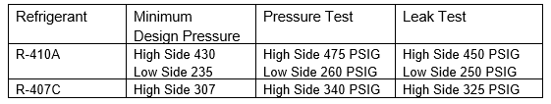
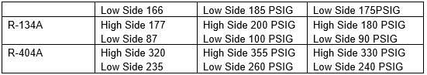

NOTE: It is acceptable to test the low side of the refrigeration system at the high side test pressure, IF all low side components, including evaporator coil, are rated for the high side pressure.

If testing of the low side and the high side are done at different pressures, provide positive isolation of the two sides, using field installed isolation valves and/or service valves that are provided as part of the equipment.

In accordance with ASME B31.5 – 538.4.2(f) – for large systems that are not completely visible to the testing operator, the pressure in the system shall be gradually increased to one-half of the test pressure, after which the pressure shall be increased in steps of approximately one-tenth of the test pressure until the required test pressure has been reached. The test shall be continuously maintained for at least 10 minutes. It may then be reduced to the leak test pressure.

CAUTION: Do not use oxygen, acetylene, or other flammable / combustible gases or gas mixtures for pressure or leak testing.

Test #2 – Leak Testing

After successful completion of Test #1, follow requirements of ASME B31.5 538.4.3 Leak Test outlined below –
- Examination for leaks shall be by the gas and bubble formation testing as detailed in ASME BPVC, Section V, article 10, or by other methods of equal sensitivity.
- ASME B31.5 specific Bubble Leak Testing shall be conducted only by qualified ES-EPD Field Engineers and ES-FE Inspectors, or others qualified under the LANL ES-FE procedure. See LANL ES-FE Chief Inspector for qualification program requirements.
- Examination shall be made of all joints and connections. The piping system shall show no evidence of leaking.
- If using bubble and gas formation testing, it must meet requirements ASME BPVC, Section V, Article 10 requirements – at a minimum, a written testing procedure, and performed by individuals with experience and training. This may be a subcontractors in-house program, nationally recognized certifications, or other acceptable qualification to the LANL Building Dept. Chief Inspector.
- If using bubble and gas formation method, use only approved leak detection solutions – not soapy bubbles…
- The pressure used for leak tests shall be either the design pressure, or a pressure specified in the engineering design.

RE-TESTING -

If piping does not pass any portion of the above tests, locate and repair leaks and repeat testing procedure until satisfactory results are obtained. Make piping repairs with new materials. Caulking on screwed joints, cracks, or holes is not acceptable.

Verification of visual examination, pressure testing and leak testing to be performed by LANL Personnel for self performed scope of work. As such the LANL Field Engineer is the Code Examiner and the Owner’s Inspector in accordance with LANL processes and procedure. The single signature on the test report signifies both.

___________________________________________________________________
Signature Date

GENERAL TEST PROCEDURE FOR PNEUMATIC PRESSURE TESTS – ASME B31.5

- If testing volume is greater than 2 cubic feet, LANL Pressure Safety Officer will need to approve of the plan

- Superintendents shall verify that the test personnel have adequate training and understanding of the test scope and process.

- For any pneumatic pressure test a temporary barricade comprised of Red Danger Tape and Signs shall be offset a minimum of 15’ surrounding the entire pressurized system. Note: This may entail barricading the doors.
CAUTION: Ensure test pressures specified are not exceeded during this stage of work.

- A manifold gauge assembly shall be used, in conjunction with a calibrated pressure gauge or pressure sensor accurate within two percent (2%) of full range with the test pressure within the middle third for the gauge.

- Clear extraneous personnel from the testing area. Only essential personnel conducting test shall be present.

- Hold test pressure for at least 10 minutes.

- If any leaks are found, the Pressure Test shall be terminated and the system returned to construction personnel for rework. In all cases when depressurizing, perform in a controlled manner through the test system vent valve.

- If no leaks are found, the Pressure Test shall be declared acceptable and Leak test will proceed. All joints will be examined as outlined in ASME B31.5 538.4.3(a), this test plan and associated records (Test Report, Inspection Report, boundary drawings, etc.) shall be submitted as the project record of these tests.

- Once tests are complete, Construction is responsible for requirements of Spec. 23-2300, and evacuation of piping as required, by design documents, which is outside of this test plan.

- Restored system to be visually examined as required to ensure all blinds have been removed and flanges re-assembled and properly torqued.

- System engineer is responsible for verifying the final configuration of all of the valves and instruments. This work is outside the scope of this leak test plan.

Test Area Signage
ATTACHMENT B

WI-400-260-FM04 Pressure Test Data Sheet example –

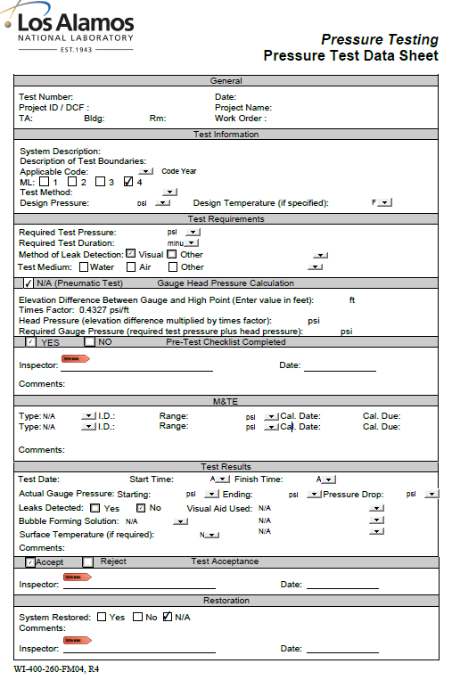

ASME B31.5 specific Leak Test Data Sheet example –

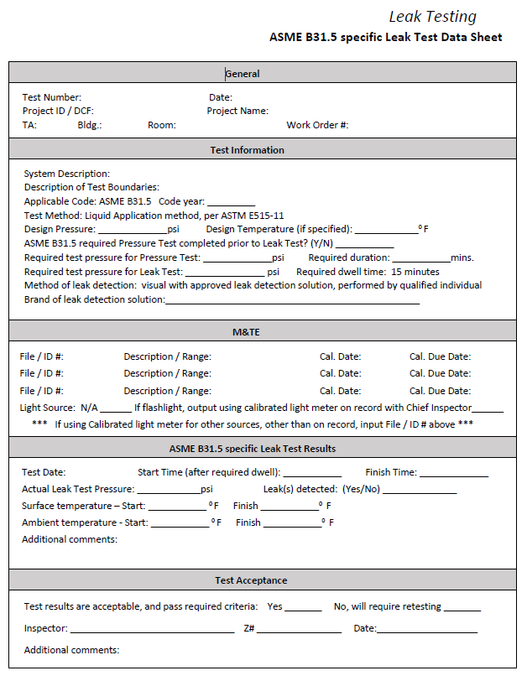

TEST #1 Pressure Test
Pneumatic Pressure Test for each refrigerant piping circuit– Pre-test Check.
☐ System designators are as shown on Boundaries sheet attached
☐ Test boundaries are identified. [See attached ).
☐ Test pressure. _____________
☐ Test medium. ______________________
☐ Test duration. ______________________
☐ System walkdown complete.
☐ Installed per design & latest changes.
☐ System is complete. Comments_________________________________
☐ Joints are exposed. Comments_________________________________
☐ System is accessible. Comments________________________________
☐ Test Rig Setup –
☐ Use calibrated pressure gauge
☐ Verify test gauge calibration is current. Record on Pressure Test Data Sheet.
☐ Test gauge is installed on system or downstream of isolation valve on leak test setup.
☐ Isolation valve is installed on leak test setup for system isolation once pressurized.
☐ Ensure all fittings, hoses and other components used to connect leak test setup to the system are rated for the test pressure being applied.
☐ Verify correct PRV, in accordance with requirements of ASME B31.5 538.4.2 is included
☐ Isolated/excluded components are noted on the leak test boundary drawing.
☐ Verified with Superintendent that the test personnel are familiar with the test requirements and have the appropriate training for working with pressure systems.
☐ Pre-test check completed by:
______________________________________________________
Printed Name Signature Date
TEST #2 Leak Test
Leak Test for each refrigerant piping circuit– Pre-test Check.
☐ Test pressure. ______________
☐ Test medium. ________________________
☐ Test duration. ________________________
☐ System walkdown complete.
☐ Installed per design & latest changes.
☐ System is complete. Comments_________________________________
☐ Joints are exposed. Comments_________________________________
☐ System is accessible. Comments________________________________
☐ Test Setup –
☐ Use calibrated pressure gauge
☐ Verify test gauge calibration is current. Record on Pressure Test Data Sheet.
☐ Leak Detection Solution used for Bubble testing.____________________
☐ Bubble test procedure available on site ___________________________
☐ Test gauge is installed on system or downstream of isolation valve on leak test setup.
☐ Isolation valve is installed on leak test setup for system isolation once pressurized.
☐ Ensure all fittings, hoses and other components used to connect leak test setup to the system are rated for the test pressure being applied.
☐ Isolated/excluded components are noted on the leak test boundary drawing.
☐ Verified with Superintendent that the test personnel are familiar with the test requirements and have the appropriate training for working with pressure systems.

☐ Pre-test check completed by:
______________________________________________________
Printed Name Signature Date

