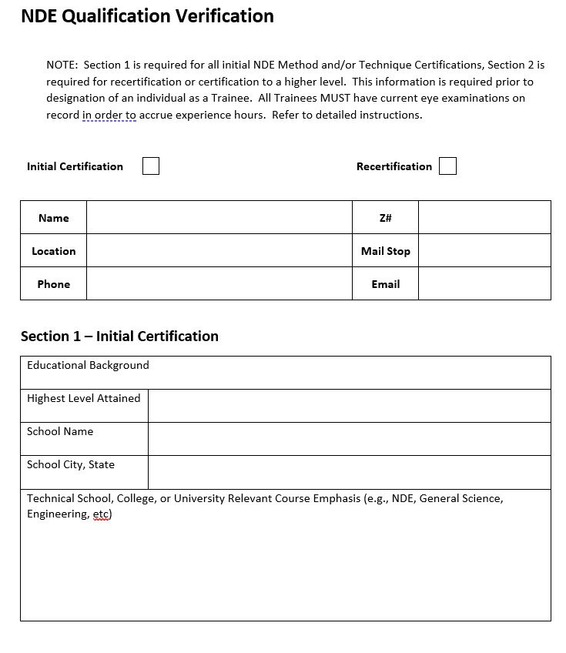

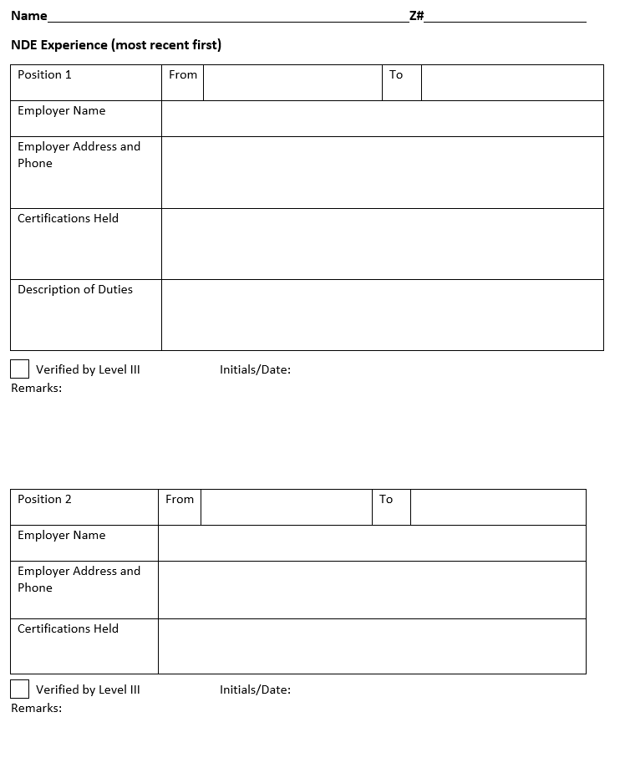

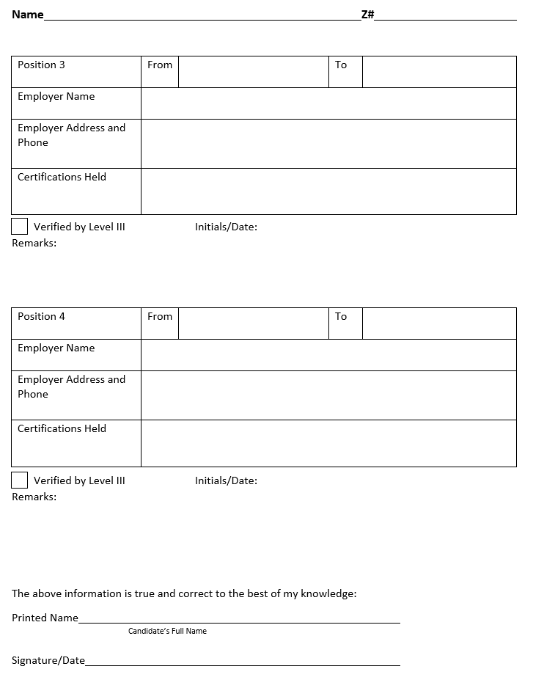

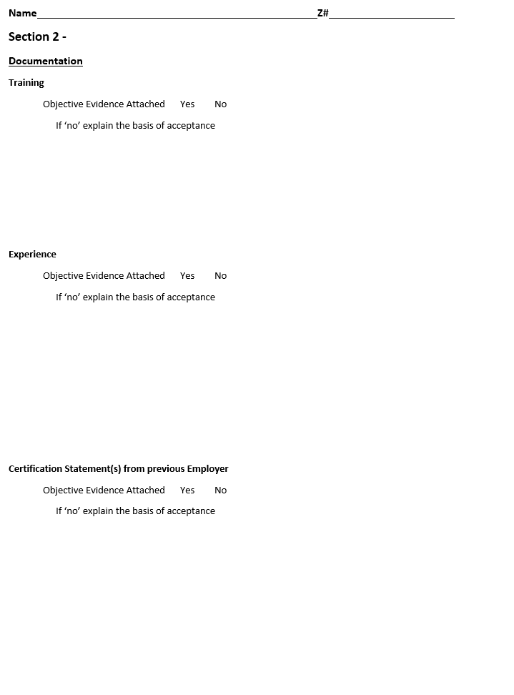

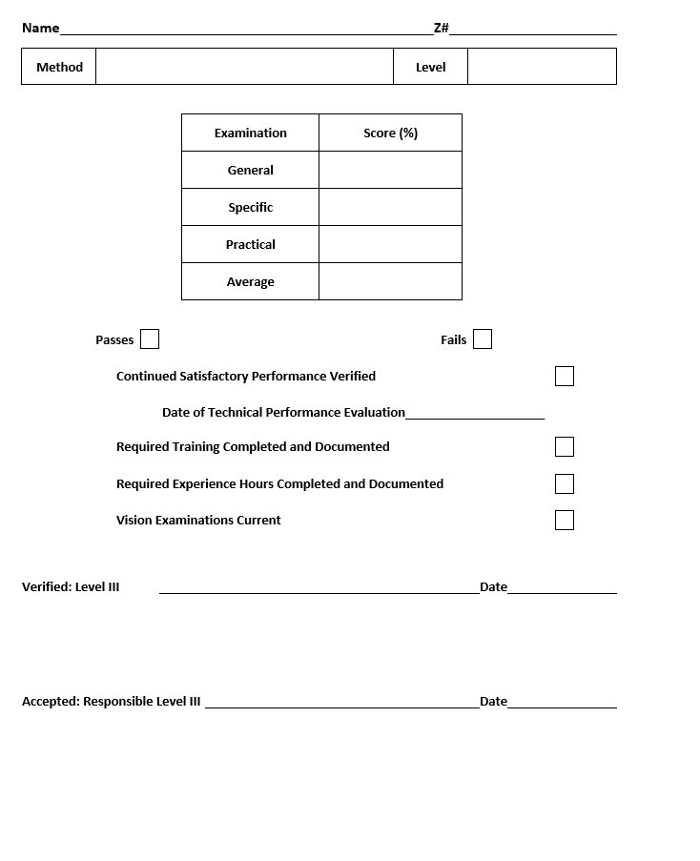

Instructions
This document provides the Level III and the Responsible Level III with a record of verification of qualification of a candidate for certification or recertification in NDE. This document becomes a record when complete and is to be stored electronically with the individual’s documentation of qualification.
- Check the appropriate box, “Initial Certification” or “Recertification”.
- Complete the identifying information required.
- Section 1 is for initial certification. If the individual has already been certified at LANL, this information is not required if verified to be on file.
- For new-hires, or those claiming experience from other employers, the Level III must verify the prior certification, whether or not the individual can present documents such as certificates or logbook entries.
- The candidate for initial certification must sign and date this information and certify it to be true and correct.
- Section 2 is for all personnel.
- Is objective evidence of training attached? Objective evidence consists of certificates of completion or a letter (on Company letterhead) from the training provider stating the dates of training and that the candidate did in fact attend and successfully complete the course. If objective evidence is not attached or on file, explain the basis for acceptance.
- Is objective evidence of experience (hands-on experience or OJT) attached? Objective evidence consists of reports, logbook entries, etc. A memorandum from a supervisor stating that an individual has XXX hours of experience is not acceptable as objective evidence. If objective evidence is not attached or on file, explain the basis for acceptance.
- For individuals claiming NDE experience from previous employment, objective evidence is required and verification of the validity of that documentation must be obtained by the Level III. If not, explain the basis for acceptance.
- The score sheet must be completed for each Method and/or Technique. Continued Satisfactory Performance, Required Training, Experience Hours, and a Current Vision Examination must be verified prior to certifying a candidate. For initial certification in a Method and/or Technique, a Technical Performance Evaluation is not required.
- The LANL NDE Level III performing the verification of qualification signs this document. If there is not another Level III to perform the verification, the Responsible Level III may sign both “verified” and “accepted”.
- The LANL Responsible NDE Level III signs as a “checker”.

