Section 01 4455
Onsite Welding, Brazing and Joining Requirements

*************************************************************************************************************

LANL MASTER SPECIFICATION SECTION
​Rev. 5 Summary of Changes: Edited and updated as required for import into SpecLink.

NOTE TO SPECIFIER ON USAGE IN SPECLINK: Activate the Section by turning on Seq #0000, followed by activating paragraphs in PART 1, Article SECTION INCLUDES. This will activate related articles, paras/subparas in the rest of the Section (i.e., SECTION INCLUDES in PART 1 activates articles and paras/subparas in PARTS 2 and 3). If there are choice fields to edit the entire Section (typically in this first author note or beginning of the Section), make selections at those locations, which will filter through the remaining Section. All Articles, paragraphs and subparagraphs must be activated sequentially from top to bottom, unless noted otherwise.

This template must be edited for each project. In doing so, Specifier must add job-specific requirements. Selections and choice fields are used to indicate designer choices or locations where text must be supplied by the designer. The section must also be edited to remove requirements for processes, items, or designs that are not included in the project.

To seek a variance from applicable requirements in this Section, contact the Engineering Standards Manual (ESM) Welding POC (LANL access only). Please contact POC with suggestions for improvement as well. LANL personnel should submit here: Suggested Change or Request Clarification; subcontractors via email to engstandards@lanl.gov.

When assembling a specification package, include applicable sections from all Divisions, especially Division 1, General Requirements.

This specification section is suitable for ML-1 through ML-4 projects.

Project is responsible for obtaining all project record documents.

This Section includes administrative and procedural requirements for onsite welding activities. It is designed to be used in conjunction with other specification sections that invoke project specific requirements as well as applicable codes & standards for welding. This Section shall be used with << 01 4525 - Non-Destructive Examination (NDE) Requirements>>.

*************************************************************************************************************
  - PART 1 - GENERAL
    - SUMMARY
      - Section Includes: Requirements for welding, brazing and joining on the LANL site as required by other specification sections, consensus codes and standards, and/or engineering design for ​<< Click to select ML(s) from drop down menu; ML-1; ML-2; ML-3; and ML-4>>​ work. See Appendix A of this Section for onsite welding overview.
      - Pressure-retaining code-stamped items shall only be welded on by organizations with the applicable ASME or National Board Certificate(s) of Authorization. Certificate holders are organizations that have been authorized by the ASME and/or The National Board to perform various activities in accordance with the requirements of the ASME Boiler and Pressure Vessel Code and/or The National Board.
      - Offsite welding shall be in accordance with design documents, applicable codes and standards, and Section ​<< 01 4444 - Offsite Welding, Brazing and Joining Requirements>>​.
      - Examination/Inspection of welding is addressed by Section << 01 4525 - Non-Destructive Examination (NDE) Requirements>>.
      - The LANL Welding Program and General Welding Standards (GWSs) referenced are available on the LANL Engineering Standards website (refer to LANL ESM Chapter 13 - Welding, Joining & NDE).

***************************************************************************************

Section << 01 4000 - Quality Requirements - Non-Nuclear>>, Section << 01 4001 - Quality Requirements - Nuclear>>​ and Section << 01 4631 - Welding, Brazing, and Soldering of Pressure Systems>> are not referenced in the body of this Section. Including these are a designer-choice.

***************************************************************************************
    - RELATED REQUIREMENTS
      - Section << 01 3300 - Submittal Procedures>>​
      - Section << 01 4000 - Quality Requirements - Non-Nuclear>>​
      - Section << 01 4001 - Quality Requirements - Nuclear>>
      - Section << 01 4444 - Offsite Welding, Brazing and Joining Requirements>>​
      - Section << 01 4525 - Non-Destructive Examination (NDE) Requirements>>​
      - Section << 01 4631 - Welding, Brazing, and Soldering of Pressure Systems>>​
    - REFERENCE STANDARDS
      - 49 CFR 192 - Transportation Of Natural and Other Gas By Pipeline: Minimum Federal Safety Standards.
      - ASME B31.3 - Process Piping.
      - ASME B31.9 - Building Services Piping.
      - AWS D1.1/D1.1M - Structural Welding Code - Steel.
    - DEFINITIONS
      - For definitions and acronyms, refer to COE Glossary of Terms. Definitions exist for the following terms: Certified Material Test Report (CMTR), ML, Procedure Qualification Records (PQR), Qualification, SSC, STR, and Welding Procedure Specifications (WPS), among others.
      - CWI: Certified Welding Inspector
      - ESM: Engineering Standards Manual
      - GWS: General Welding Standards
      - PQR: Procedure Qualification Records
      - SME: Subject Matter Expert
      - STR: Subcontract Technical Representative
      - WPQR: Welder/Brazer/Bonder Performance Qualification Records
      - WPS/BPS: Welding/Brazing Procedure Specifications with supporting PQRs
    - ACTION SUBMITTALS
      - For Onsite welding, when using LANL WPS/PQRs and WPQRs, include those in the project work package. Note, no submittal of these is required. The project is responsible for obtaining all project record documents.
      - The following documents shall be submitted and approved by LANL Welding Program SME prior to the start of welding. Submit per Section << 01 3300 - Submittal Procedures>>. Do not submit with reference to this Section, but rather to the Div 02–48 Sections to which they apply, unless otherwise indicated. Each numbered item should be a separate submittal. These submittals are discussed in greater detail later in this Section.

******************************************************************************

The subparagraph below is only required as a submittal for Onsite welding, when subcontractor not using LANL WPS/PQR.

******************************************************************************
        - Welding/Brazing/Bonding Procedure Specifications with the associated Procedure Qualification Records (PQRs).

******************************************************************************

The subparagraph below is only required as a submittal for Onsite welding, when subcontractor not tested at LANL.

******************************************************************************
        - Welder/Brazer/Bonder Performance Qualification Records (WPQR) and continuity logs/statement if welding certifications are greater than six months old.

******************************************************************************

The following two subparagraphs apply to ML-1 or ML-2 work. Designer may choose to include CMTRs for ML-3 or ML4 work depending on project-specific requirements.

******************************************************************************
        - Weld Filler Material Control Procedure for ML-1 and ML-2 applications
        - Filler Material Certified Material Test Reports (CMTRs) for ML-1 and ML-2 applications.
        - Post-Weld Heat Treatment Procedures (where applicable).
    - WELDING CHECKLIST
      - A Welding Checklist shall be completed prior to onsite welding to ensure that the specific requirements for welding activities have been identified and addressed. Welding Checklist shall be signed by a LANL CWI. The Welding Checklist is available on the LANL Engineering Standards Website (refer to LANL ESM Chapter 13 - Welding, Joining & NDE, GWS 1-03, Att. 7).

***************************************************************************************

Omit Article Design below if design is provided by LANL.

***************************************************************************************
    - DESIGN
      - Design of welded structures, systems and components (SSC) shall meet the requirements of LANL ESM and as a minimum identify applicable codes and standards including requirements of graded application. For welding activities that would normally fall outside the defined scope of specified national consensus codes and standards for fabrication and welding, such codes and standards shall be adopted and used to the extent possible.

***************************************************************************************

Numerous codes & standards define graded approaches which specify multiple levels of welding requirements. Designs which specify the codes & standards listed below shall also specify service or category and applicable welding requirements these codes identify. For example:

- ASME B31.1 – Material, Temperature, & Pressure

- ASME B31.3 – Service Categories, D, Normal, M, & High Pressure

- ASME B31.5 – Safety Group A3 & B3

- ASME B31.8 – Class, location

- 49 CFR Part 192 – Class, location

- AWS D1.1/D1.1M – Static, Cyclic, and Tubular Structures

- AWS D1.6/D1.6M – Static, Cyclic

***************************************************************************************
      - Engineering drawings shall specify all fillet weld sizes and partial penetration weld sizes.
      - Shop drawings shall show weld symbols and requirements to define the work and enable design review and inspection this shall include fillet weld sizes and partial penetration weld sizes.

***************************************************************************************

When all welding is to a code, do not include paragraph below regarding non-code equivalent work.

***************************************************************************************
      - Applications that are not similar in materials or processes to a specified code or standard shall define and produce the following:
        - Design basis i.e., mechanical properties, part geometry, acceptance criteria.
        - A method to verify that the welding procedure can produce acceptable welds
        - A method to demonstrate that the welder has the skill to produce sound welds in accordance with the specified welding procedure (refer to LANL ESM Chapter 13 - Welding, Joining & NDE, GWS 1-02, Administrative Control of Welding and Brazing (e.g., para 5.3.B in R7)).
        - Identify methods and perform inspections, required to judge welds against predetermined acceptance criteria.
        - Provide documentation that these objectives have been defined and identified.
    - Qualified Procedures
      - Welding and brazing shall be performed in accordance with LANL welding/brazing procedure specifications (WPS/BPS) that have been qualified in accordance with applicable codes and standards or design criteria:
        - LANL welding/brazing procedure specifications shall be used and are located on the LANL Engineering Standards website (refer to LANL ESM Chapter 13 - Welding, Joining & NDE, Quick Links, LANL WPS Index).
        - Heat treating as required.
    - QUALIFIED/CERTIFIED PERSONNEL
      - Welding and brazing shall be performed by welders and brazers who have demonstrated their welding/brazing skill by test at LANL and are LANL-certified.
        - Current listing of certified welders/brazers is located on the LANL Engineering Standards website (refer to LANL ESM Chapter 13 - Welding, Joining & NDE, Quick Links, Welder Qualification Database (LANL access only)).
        - WPQR: LANL Welder/brazer/bonder performance qualification records and welder continuity tracking are in LANL ESM Chapter 13 - Welding, Joining & NDE.
      - Joining (solvent bonding, adhesive, fusion and electro-fusion joints): When required by consensus codes and standards (e.g., <<ASME B31.3>>, <<ASME B31.9>>, <<AWS D1.1/D1.1M>>, <<49 CFR 192>> etc.) joining shall be done by LANL-qualified personnel following LANL-approved procedures.
    - Procurement & Control of Consumables
      - Subcontractors are responsible to supply filler material meeting the requirements defined in LANL ESM Chapter 13 - Welding, Joining & NDE, GWS 1-03 and attachments unless filler material is to be government-furnished by subcontract. On a case-by-case basis as authorized by the responsible LANL STR, LANL-stocked filler material may be issued. LANL will disburse daily quantities to those with proper paperwork (LANL STR approval, Welding Checklist, and Weld Material Request); they will also issue bulk quantities to those maintaining LANL Authorized Filler Material Issue Locations (LANL access only). A list of stocked filler material is located on the LANL Engineering Standards website (refer to LANL ESM Chapter 13 - Welding, Joining & NDE, Quick Links, Filler Material - Warehouse Stocked).
      - The procedure for procurement, storage, issue and control of consumables is found in LANL ESM Chapter 13 - Welding, Joining & NDE, GWS 1-03.

***************************************************************************************

The following paragraph and subparagraphs apply to ML-1 or ML-2 work. Designer may choose to include CMTRs for ML-3 or ML4 work depending on project-specific requirements.

***************************************************************************************
      - Filler material shall be procured with Certified Material Test Reports (CMTRs) traceable by heat/lot number.
        - For Structures, Systems and Components (SSCs) that are designated ML-1 (safety class) or ML-2 (safety significant), welding consumables shall be provided with CMTRs traceable by heat/lot number to the point-of-use.
        - Certified Material Test Reports (CMTRs) shall meet the requirements of AWS A5.XX Standards for Welding Filler Materials. Reports shall detail physical and chemical properties of the material(s) and be in accordance with the applicable national or international material standards (e.g., ASTM, ASME) for the material type. CMTRs must be the results of test performed by the material manufacturer or by a material verification process, if such a process is allowed by the standard governing the material type, and must specify the test method and the source of the acceptance criteria. Each CMTR must be signed by an authorized representative of the testing entity, be traceable to the materials delivered via heat, lot, or other identification, and must meet any content requirements of the applicable national or international standards invoked for the material type.
      - Filler materials shall be issued from approved locations by authorized personnel to qualified welders.
        - LANL Authorized Filler Material Issue Locations (LANL access only)
    - WELDING, BRAZING, JOINING AND NDE ACTIVITIES
      - LANL may elect to have its own qualified inspectors and/or personnel present during all welding, brazing, joining and NDE activities for oversight.
        - Hold and Witness Points may be identified in the construction/fabrication schedule to allow for LANL’s inspection activities.
    - SUB-tIER Subcontracted Welding
      - Submittal requirements apply to all sub-tier welding activities.
      - Subcontracted welding activities shall have all applicable specifications sections and drawings and their applicable requirements flowed down to any sub-tier who is to perform those welding activities.
      - Requirements for subcontracted welding shall be identified in Sub-tier Subcontract documents as outlined in LANL ESM Chapter 13 - Welding, Joining & NDE, GWS 1-09, Control of Subcontracted Welding.
  - PART 2 - PRODUCTS (Not Used)
  - PART 3 - EXECUTION (Not Used)
  - END OF MAIN SECTION; APPENDIX FOLLOWS

**********************************************************************************************

Do not omit the following reference information:

**********************************************************************************************
  - THE FOLLOWING STATEMENT IS FOR LANL USE ONLY
  - THIS PROJECT SPECIFICATION SECTION IS BASED ON LANL MASTER SPECIFICATION SECTION 01 4455, REV. 5, DATED APRIL 15, 2026.
  - 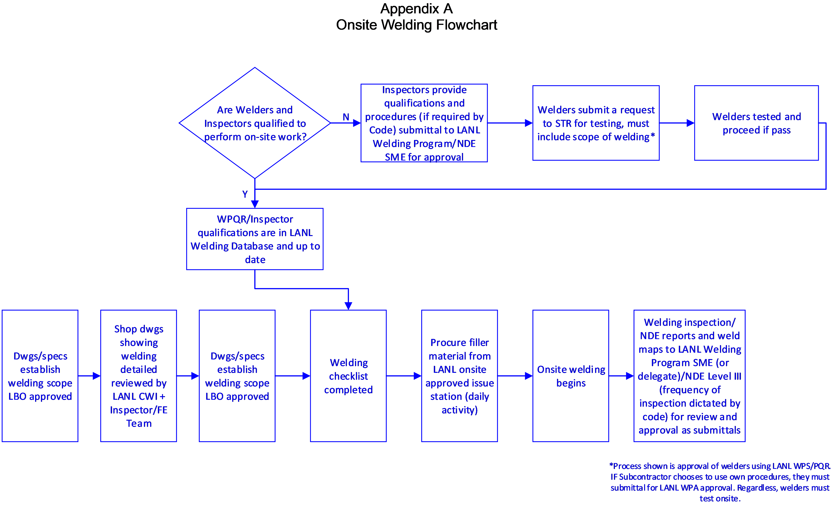
END OF SECTION

