Section 01 4631
Welding, Brazing, and Soldering of Pressure Systems

************************************************************************************************************

LANL MASTER SPECIFICATION Section
Rev. 3 Summary of Changes: Edited and updated as required for import into SpecLink.

NOTE TO SPECIFIER ON USAGE IN SPECLINK: Activate the Section by turning on Seq #0000, followed by activating paragraphs in PART 1, Article SECTION INCLUDES. This will activate related articles, paras/subparas in the rest of the Section (i.e., PART 1 activates articles and paras/subparas in PARTS 2 and 3). If there are choice fields to edit the entire Section (typically in this first author note or beginning of the Section), make selections at those locations, which will filter through the remaining Section. All Articles, paragraphs and subparagraphs must be activated sequentially from top to bottom, unless noted otherwise.

This template must be edited for each project. In doing so, Specifier must add job-specific requirements. Selections and choice fields are used to indicate designer choices or locations where text must be supplied by the designer. The section must also be edited to remove requirements for processes, items, or designs that are not included in the project.

To seek a variance from applicable requirements in this Section, contact the Engineering Standards Manual (ESM) Pressure Safety/Welding POC (LANL access only). Please contact POC with suggestions for improvement as well. LANL personnel should submit here: Suggested Change or Request Clarification; subcontractors via email to engstandards@lanl.gov.

When assembling a specification package, include applicable specifications from all Divisions, especially Division 1, General Requirements.

Section is developed for ML-4 projects. For ML-1, 2, and 3 applications, additional requirements and independent reviews should be added if increased confidence in procurement or execution is desired; see LANL ESM Chapter 1 - General, Section Z10 Specifications and Quality sections.

==========================================================

This template material was developed to meet the requirements for ASME B31.9-2020, B31.1-2020, B31.5-2019, and ASME B31.3-2020. The type of fluid service must be specified to ensure the correct process is used for the application. Application of this template to a different fluid service or edition of these ASME code editions will require a detailed review of the code and LANL ESM Chapter 17 - Pressure Safety. In addition, LANL utilizes a risk-based approach related to personnel injury (FS1, FS2, and FS3) described by LANL Procedure P101-34 that is used herein.

This is not a typical LANL master. It is verbiage and examples of welded-joint design/fab final design (e.g., thicknesses) that the Design Agency must convey to the Constructor/fabricator. Conveying this can be accomplished in several ways:

- Option 1: Include this Section in the Specification while ensuring that (a) ​<< 01 4631 - Welding, Brazing, and Soldering of Pressure Systems>>​ is invoked by the technical sections (in Div. 22, 23, 40, etc.) and (b) those Sections are clear that the submittals discussed here are always sent in per the affected Div. 02-48 section.

Option 2: Including applicable material herein on the drawings and/or in the Spec (again, delete all references to this Section in Spec book) (NOTE: Option 2 is the least desirable option).

This document captures LANL’s ASME B31 welding requirements once (rather than in multiple sections) for LANL’s convenience in maintaining the requirements. It is provided as an aid to the Design Agency for providing a complete, code-compliant design that LANL can review and accept during the design phase. Delegation and deferment of said design requires LANL Project Engineer and Pressure Safety SME prior approval.

This section addresses both welding, brazing, and soldering of ASME B31 piping and tubing. As such, it potentially affects (but is not limited to) the following related LANL Masters:

Section 11 5311.18 - Glovebox Atmosphere Regenerable Purification Systems

Section ​<< 22 0529 - Hangers and Supports for Plumbing Piping and Equipment>>​

Section ​<< 22 1500 - Compressed-Air Systems>>​

Section ​<< 23 1123 - Facility Natural-Gas Piping>>​

Section ​<< 23 2113 - Hydronic Piping>>​

Section ​<< 23 2215 - Steam and Condensate Heating Piping and Specialties>>​

Section ​<< 23 2300 - Refrigerant Piping>>​

Section ​<< 25 5000 - Integrated Automated Facility Controls>>​

Section ​<< 33 5100 - Natural Gas Distribution>>​

Section ​<< 33 6300 - Steam Energy Distribution>>​

Section ​<< 40 0504 - Process Piping>>​

Note, if packaged units are not being used, i.e., coils are specified in any of the below-mentioned specification section, they need to be referenced in Article 1.2 Related Requirements.

Section ​<< 23 6200 - Packaged Compressor and Condenser Units>>​

Section ​<< 23 7413 - Packaged Outdoor Central-Station Air-Handling Units>>​

Section

Sections ​<< 01 4444 - Offsite Welding, Brazing and Joining Requirements>>​ and ​<< 01 4455 - Onsite Welding, Brazing and Joining Requirements>>​ which address welder and procedure qualification are complementary to this section (and to non-B31 welding sections) and should continue to be included where welding is involved.

Section ​<< 01 4525 - Non-Destructive Examination (NDE) Requirements>>​ addresses nondestructive examination (NDE) (offsite and onsite) and is complementary to this section and should continue to be included where NDE is involved.

The designer is encouraged to review the DOE Handbook DOE-HDBK-1132, Design Considerations, and the LANL Engineering Standards Manual Chapters 13 and 17.

************************************************************************************************************
  - Part 1 - GENERAL
    - Section Includes
      - Detailed requirements for welding/brazing/soldering of <<ASME B31>> series piping, tubing, and components as required by the design.

**********************************************************************************************

The following Sections 11 5311.18, Glovebox Atmosphere Regenerable Purification Systems and << 23 1123 - Facility Natural-Gas Piping>> are not referenced in the body of this Section. Including them are a designer choice. Div 11 spec sections are not in SpecLink and need to be downloaded from the Engineering Standards specification website to include in the specification package, as applicable.

**********************************************************************************************
    - related requirements
      - Section ​<< 01 3300 - Submittal Procedures>>​.
      - Section ​<< 01 4444 - Offsite Welding, Brazing and Joining Requirements>>​
      - Section ​<< 01 4455 - Onsite Welding, Brazing and Joining Requirements>>​
      - Section ​​<< 01 4525 - Non-Destructive Examination (NDE) Requirements>>​​
      - Section 11 5311.18, Glovebox Atmosphere Regenerable Purification Systems
      - Section ​​<< 22 1500 - Compressed-Air Systems>>​​
      - Section ​<< 23 1123 - Facility Natural-Gas Piping>>​
      - Section ​<< 23 2113 - Hydronic Piping>>​
      - Section ​<< 23 2215 - Steam and Condensate Heating Piping and Specialties>>​​
      - Section ​<< 23 2300 - Refrigerant Piping>>​
      - Section ​​<< 33 5100 - Natural Gas Distribution>>​​​
      - Section ​<< 33 6300 - Steam Energy Distribution>>​
      - Section ​<< 40 0504 - Process Piping>>​​

***************************************************************************************

In the listing below, designer must eliminate standards that are not applicable to the project and add standards that are applicable to the project. Then, designer must either (1) specify each ASME B31.1, B31.3, B31.5, or B31.9-listed materials’ national standard edition for each remaining standard listed or (2) determine latest is equivalent. Then modify to either (1) implement the first option—and also list the edition year after each standard number (e.g., ASTM F493-04)—or (2) implement the second option.

AWS material specifications have been qualified per ASME Section IX as required by ASME B31.3 328.3.1

LANL ESM Chapter 13 - Welding, Joining & NDE provides links to the LANL approved welding and brazing procedures. Other procedures may be used provided they are approved by the process in Section << 01 4444 - Offsite Welding, Brazing and Joining Requirements>> or Section << 01 4455 - Onsite Welding, Brazing and Joining Requirements>>.

***************************************************************************************
    - Reference STANDARDS
      - ​​<< All national standards invoked herein shall be taken to be the edition in effect for the code of record listed above in Related Requirements and shown below, unless noted otherwise; or All national standards invoked below and herein shall be taken to be the latest edition in published as of the issue date of Section in Related Requirements.>>​​.
      - 49 CFR 192 - Transportation Of Natural and Other Gas By Pipeline: Minimum Federal Safety Standards.
      - API 1104 - Welding of Pipelines and Related Facilities.
      - ASME B31.1 - Power Piping.
      - ASME B31.3 - Process Piping.
      - ASME B31.5 - Refrigeration Piping and Heat Transfer Components.
      - ASME B31.8 - Gas Transmission and Distribution Piping Systems.
      - ASME B31.9 - Building Services Piping.
      - ASME BPVC-IX - Boiler and Pressure Vessel Code, Section IX - Qualification Standard for Welding, Brazing, and Fusing Procedures; Welders; Brazers; and Welding, Brazing, and Fusing Operators.
      - ASTM B32 - Standard Specification for Solder Metal.
      - ASTM B813 - Standard Specification for Water Flushable Liquid and Paste Fluxes for Soldering of Copper and Copper Alloy Tube.
      - ASTM B828 - Standard Practice for Making Capillary Joints by Soldering of Copper and Copper Alloy Tube and Fittings.
      - ASTM D2564 - Standard Specification for Solvent Cements for Poly(Vinyl Chloride) (PVC) Plastic Piping Systems.
      - ASTM F714 - Standard Specification for Polyethylene (PE) Plastic Pipe (DR-PR) Based on Outside Diameter - 2013 (ASME B31.3).
      - ASTM F2620 - Standard Practice for Heat Fusion Joining of Polyethylene Pipe and Fittings.
      - AWS A5.1/A5.1M - Specification for Carbon Steel electrodes for Shielded Metal ArcWelding.
      - AWS A5.4/A5.4M - Specification for Stainless Steel electrodes for Shielded Metal Arc Welding.
      - AWS A5.8M/A5.8 - Specification for Filler Metals for Brazing and Braze Welding.
      - AWS A5.9/A5.9M - Specification for Bare Stainless Steel Welding Electrodes and Rods.
      - AWS A5.18/A5.18M - Specification for CarbonSteel Electrodes and Rods for Gas Shielded Arc Welding.
      - AWS D1.1/D1.1M - Structural Welding Code - Steel.
      - MSS SP 97 - Integrally Reinforced Forged Branch Outlet Fittings: Socket Welding, Threaded, and Buttwelding Ends.

***************************************************************************************

The following information shall be submitted for all relevant components to the Div 02-48 section to which they apply.

***************************************************************************************
    - ACTION Submittals

NOTE: The following information shall be submitted for all relevant components to the Div 02-48 section to which they apply. Submittals shall be in accordance with Section << 01 3300 - Submittal Procedures>>​.
      - Prior to receiving materials, submit the Material Control Procedure described in Article << 1.5; or _______>>Quality Control and Quality Assurance.
      - Before fabrication, submit NDE (non-destructive examination) procedures that will be used for fabrication and examination of the piping, and pressure-leak testing. Refer to Section << 01 4525 - Non-Destructive Examination (NDE) Requirements>>.
      - Before fabrication, submit Qualifications of NDE Personnel in accordance with applicable code(s) of record. Refer to Section ​<< 01 4525 - Non-Destructive Examination (NDE) Requirements>>​.
      - Submit cleaning procedures for pre and post operations.
      - After fabrication, submit NDE Reports per Section << 01 4525 - Non-Destructive Examination (NDE) Requirements>>.
    - Quality Control and Quality Assurance

***************************************************************************************

NOTE: An example procedure is LANL ESM Chapter 13 - Welding, Joining & NDE, General Welding Standards 1-03 Welding and Brazing Material Procurement & Control, that describes how LANL does this material control.

***************************************************************************************
      - Material Control Procedure (in accordance with management level requirements):
        - Work shall be performed in accordance with a LANL-approved Material Control Procedure. This procedure shall describe the control methods and documentation used to handle and monitor the use of controlled materials (piping component, fasteners, and welding filler rod and other components). The procedure shall follow manufacturer’s requirements for storage and handling.
        - The procedure shall also address procurement controls, segregation of materials, and traceability of materials from receipt at the shop through processing and final assembly.
      - Examination, Inspection, and Testing
        - For the purposes of this section, the Subcontractor is responsible for all tasks identified as examination and testing. Certified welding inspector (CWI) activities are considered examination. Owner’s Inspector activities are considered inspection.
        - The Subcontractor shall perform examination and testing to verify the conformance to the specified requirements defined in PART 2 of this Section, as well as any Subcontractor requirements as defined as part of the Subcontractor’s QA/QC program.
        - The Subcontractor shall provide an “Test and Inspection Plan” indicating all testing, examination, and inspection functions to be performed, including hold points during fabrication and assembly, as well as during the factory acceptance testing (FAT).
        - All inspection, examination, and testing functions shall be performed by qualified personnel using qualified procedures in accordance with the design and code of record(s).
        - Hold points are required during the fabrication process to allow inspection, verification, or approval by LANL before the Subcontractor does further work. Hold points shall be identified on the “Test and Inspection Plan,” with provisions for LANL review and acceptance. LANL may waive Hold Points at their discretion.
        - Examination Records: The Subcontractor shall appropriately record, submit and maintain records documenting the examination and/or test then submit the completed record as part of the QA Document Package. The status of all planned and executed examination, inspection, and testing activities shall be logged and traceable to ensure that the required examination, inspection, and testing have been performed, and any items that have failed examination, inspection or testing are not inadvertently installed or implemented.
      - Qualifications
        - ​Installer Qualifications
          - Certify that all personnel have passed relevant qualification tests per ASME B31 Code of Record for joining processes involved and that certification is current.
            - Metallic Pipe: Welders and braziers shall be qualified in accordance with <<ASME BPVC-IX>>.
            - Plastic: Bonder and bonding operators shall be qualified per <<ASME B31.3>> Section A328.2.
            - Personnel qualifications shall be in accordance with Section(s) << 01 4444 - Offsite Welding, Brazing and Joining Requirements; and 01 4455 - Onsite Welding, Brazing and Joining Requirements>>.
            - Personnel qualifications for natural gas distribution welding shall be accordance with <<49 CFR 192>> references.

**********************************************************************

Retain the following subparagraph when metallic welding is specified.

**********************************************************************
          - Welding/Brazing procedures for metallic materials
            - Procedures shall be qualified according to <<ASME BPVC-IX>>.
            - Welding and brazing procedures shall be in accordance with Section(s) << 01 4444 - Offsite Welding, Brazing and Joining Requirements; and 01 4455 - Onsite Welding, Brazing and Joining Requirements>>.
            - Welding procedures for the natural gas distribution system shall meet <<49 CFR 192>> and by reference <<API 1104>>.

**********************************************************************

Retain the following subparagraph when non-metallic welding is specified.

**********************************************************************
          - Welding (Bonding) procedures for plastic piping
            - Welding and joining procedures shall be in accordance with Section << 01 4444 - Offsite Welding, Brazing and Joining Requirements>>​.
            - Welding and joining procedures shall be in accordance with Section ​<< 01 4455 - Onsite Welding, Brazing and Joining Requirements>>​.
            - Natural gas distribution piping procedures shall meet <<49 CFR 192>> and by reference other standards like ​<< ASTM F2620; and _______>>​.
        - Owner’s Inspector and Designee shall be qualified in accordance with <<ASME B31.3>> Section 340 and LANL’s Engineering Services Division will act for DOE to designate Owner’s Inspectors or Designee.
  - Part 2 - PRODUCTS

**********************************************************************************************

Retain paragraphs below that contain welding, brazing, or soldering. This will activate applicable row(s) in Article Welding, Brazing, and Soldering Applications. For Hydronic Piping and Process Piping applications, the designer must manually select the applicable row(s) to match the piping material(s).

The Specifier may still need to edit the details in the applicable row(s) to match the joining method(s) specified in the piping Section(s).

**********************************************************************************************
    - Piping/Tubing/Fittings
      - See Section << 22 1500 - Compressed-Air Systems>> (<<ASME B31.9>>)
      - See Section << 23 2113 - Hydronic Piping>> (<<ASME B31.9>>)
      - See Section << 23 2215 - Steam and Condensate Heating Piping and Specialties>> (<<ASME B31.9>>)
      - See Section << 23 2300 - Refrigerant Piping>> (<<ASME B31.5>>)
      - See Section << 33 5100 - Natural Gas Distribution>> (<<49 CFR 192>>)
      - See Section << 33 6300 - Steam Energy Distribution>> (<<ASME B31.1>>)
      - See Section << 40 0504 - Process Piping>> (<<ASME B31.3>>)
    - WELDING, BRAZING, AND SOLDERING APPLICATIONS

***************************************************************************************

The table below may be used as a guide to understand which general joining processes are most often applied to specific systems identified in other specification sections.

This section must be updated to reflect the assembly processes for the system. The welding design must address the following criteria:

1. Weld procedure specifications (WPS)

2. List of welding materials, to include filler materials and gases

3. Heat treatment requirements

4. Method of welding, brazing, solvent welding, thermal fusion, etc. (GTAW, SMAW, oxyacetylene, etc.)

5. Cleaning requirements

***************************************************************************************
Process Description | Section | Commodity | Materials | Weld Application | Comments
Hidden Paragraph
​<< Soldering; or Brazing>>​​ | << 22 1500>> | Compressed Air <150 psig | Copper / brass | Socket Weld fillet weld | ASME B31.9 ​​​<< Solder Metal; or Braze Metal>>​​​
Hidden Paragraph
​  Chemical Fusion | << 23 2113>> | Hydronic Piping <150 psig | PVC | Socket Weld fillet weld | ASME B31.9 Chemical Fusion
Hidden Paragraph
​  ​<< GTAW (Welding); or SMAW (Welding)>>​​ | << 23 2113>> | ​  Hydronic Piping <150 psig | ​  Carbon Steel | Socket Weld fillet weld | ASME B31.9 Filler metal
Hidden Paragraph
Brazing | << 23 2113>> | Hydronic Piping <150 psig | Copper / brass | Socket Weld fillet weld | ASME B31.9 Braze metal
Hidden Paragraph
​<< GTAW (Welding); or SMAW (Welding)>>​​ | << 23 2215>> | Steam and condensate < 150 psig | Carbon Steel | Socket Weld fillet weld | ​ASME B31.9 Filler metal
Hidden Paragraph
​​<< Brazing; or Soldering>>​​ | << 23 2300>> | Refrigerant | Copper / brass | Socket Weld fillet weld | ASME B31.5 ​​<< Braze Metal; or Solder Metal>>​​
Hidden Paragraph
​​<< SMAW (Welding); or Thermal Fusion>>​​​ | << 33 5100>> | Natural Gas Distribution | ​​​​​​​<< HDPE; Carbon steel; or ______>>​​​​​​​ | Butt Weld  full penetration | ​​​<< 49 CFR 192 Autogenous/API Procedures; or 49 CFR 192 / API Procedures>>​​​
Hidden Paragraph
​<< GTAW (Welding); or SMAW (Welding)>>​​ | << 33 6300>> | Steam Energy Distribution | Steel | ​​​<< Butt Weld full penetration; Socket Weld fillet weld; and ______>>​​​ | ASME B31.1 Filler metal
Hidden Paragraph
​<< GTAW (Welding); or SMAW (Welding)>>​​ | << 40 0504>> | ​​​​<< Argon >150 psig; or _______>>​​​​​ | Stainless Steel | Butt weld full penetration | ASME B31.3 Autogenous
Hidden Paragraph
​​<< GTAW (Welding); or SMAW (Welding)>>​​​ | << 40 0504>> | ​​​​<< Helium ≤ 150 psig; or _______>>​​​​ | Stainless Steel / Carbon Steel | MSS SP-97 full penetration and fillet weld | ASME B31.3 Bimetal weld process
Hidden Paragraph
Brazing | << 40 0504>> | ​​<< Compressed Air >150 psig; or _______>>​​ | Copper / brass | Socket Weld fillet weld | ASME B31.3 Braze metal
Hidden Paragraph
Chemical Fusion | << 40 0504>> | ​<< DI water system; or _______>>​ | PVC | Socket Weld fillet weld | ​ASME B31.3 Chemical Fusion
Hidden Paragraph
​​<< Thermal Fusion; or Thermal Fusion (Electrofusion)>>​​ | ​<< 40 0504>> | ​​​<< Radioactive Liquid Waste (RLW); or ______>>​​​ | HDPE | Butt Weld  full penetration | ASME B31.3 Normal Fluid Autogenous

***************************************************************************************

The following two rows are fully customizable for non-standard applications, i.e., when materials other than the defaults provided in the specification sections are to be used. The designer may add additional rows if necessary.

***************************************************************************************
​​​​​​​<< SMAW (Welding); GTAW (Welding); TF (Thermal Fusion Welding); Chemical Fusion (Welding); Brazing; Soldering; Combination process; and ______>>​​​​​​​​ | ​​​​​​​<< 22 1500 ; 23 1123 ; 23 2113 ; 23 2215 ; 23 2300 ; 25 5000 ; 33 5100 ; 33 6300 ; 40 0504 ; and ___>>​​​​​​​ | ​​​​​​​<< Compressed Air (150 psig or less); Compressed Air (greater than 150 psig); Hydronic Piping; Steam; Condensate; Radioactive Liquid Waste (RLW); Helium (150 psig and less); Helium (greater than 150 psig); Argon (150 psig and less); Argon (greater then 150 psig); Natural Gas (Distribution); Naturel Gas (inside building); Refrigerant; and ______>>​​​​​​​ | ​​​​​​​<< Carbon Steel; Stainless Steel; Copper; Carbon Steel to Stainless Steel; High Density Polyethylene (HDPE); Polyvinyl Chloride (PVC); and ______>>​​​​​​​ | ​​​​​​​<< Full Penetration Butt Weld; Partial Penetration Butt Weld; Fillet Weld only (Socket Weld); Full Penetration Butt Weld and Fillet Weld Cap (MSS SP97); Fillet Weld; and ______>>​​​​​​​ | ​​​​​​​<< B31.3 Weld; B31.3 Braze; B31.3 Solder; B31.5 Weld; B31.5 Braze; B31.5 Solder; B31.9 Weld; B31.9 Braze; B31.9 Solder; 49CFR192 metallic (API 1104); 49CFR192 plastic (ASTM F2620); AWS D1.1 (Piping Supports); Filler metal required; Autogenous; Thermal Fusion; Electrofusion; Solvent Bond aka Chemical Bond; Bi-Metal; and ______>>​​​​​​​
Hidden Paragraph
<< SMAW (Welding); GTAW (Welding); TF (Thermal Fusion Welding); Chemical Fusion (Welding); Brazing; Soldering; Combination process; and ______>> | ​​​​​​<< 22 1500 ; 23 1123 ; 23 2113 ; 23 2215 ; 23 2300 ; 25 5000 ; 33 5100 ; 33 6300 ; 40 0504 ; and ___>>​​​​​​ | ​​​​​​<< Compressed Air (150 psig or less); Compressed Air (greater than 150 psig); Hydronic Piping; Steam; Condensate; Radioactive Liquid Waste (RLW); Helium (150 psig and less); Helium (greater than 150 psig); Argon (150 psig and less); Argon (greater then 150 psig); Natural Gas (Distribution); Naturel Gas (inside building); Refrigerant; and ______>>​​​​​​ | ​​​​​​<< Carbon Steel; Stainless Steel; Copper; Carbon Steel to Stainless Steel; High Density Polyethylene (HDPE); Polyvinyl Chloride (PVC); and ______>>​​​​​​ | ​​​​​​<< Full Penetration Butt Weld; Partial Penetration Butt Weld; Fillet Weld only (Socket Weld); Full Penetration Butt Weld and Fillet Weld Cap (MSS SP97); Fillet Weld; and ______>>​​​​​​ | ​​​​​​<< B31.3 Weld; B31.3 Braze; B31.3 Solder; B31.5 Weld; B31.5 Braze; B31.5 Solder; B31.9 Weld; B31.9 Braze; B31.9 Solder; 49CFR192 metallic (API 1104); 49CFR192 plastic (ASTM F2620); AWS D1.1 (Piping Supports); Filler metal required; Autogenous; Thermal Fusion; Electrofusion; Solvent Bond aka Chemical Bond; Bi-Metal; and ______>>​​​​​​
    - Welding, Brazing, and Soldering processes and MATERIALS

***************************************************************************************

These AWS material specifications have been qualified per ASME Section IX as required by ASME B31.3 para. 328.3.1.

LANL ESM Chapter 13 - Welding, Joining & NDE has a link to the approved LANL Welding and brazing procedures: LANL WPS INDEX.

Non-LANL derived welding and brazing procedures may be utilized if submitted in accordance with Section ​<< 01 4444 - Offsite Welding, Brazing and Joining Requirements>>​ or Section ​<< 01 4455 - Onsite Welding, Brazing and Joining Requirements>>​.

***************************************************************************************
      - Stainless Steel Pipe Welding
        - LANL WPS 1000-0213-8
        - Process: SMAW
        - Filler Metal: <<AWS A5.4/A5.4M>>, << E316L-15; E316L-16; or E316L-17>>
        - Fillet Weld (Socket Joint): ​<< Joint 1; and Joint 2>>​
      - Stainless Steel Pipe Welding
        - LANL WPS 2010-0212-8
        - Process: GTAW
        - Filler Metal: <<AWS A5.9/A5.9M>> ER316L

******************************************************************************

The following two subparagraphs are designer choices.

******************************************************************************
        - Pipe Groove Weld: ​​​<< Joint 1; Joint 2; and Joint 3>>​​​
        - Fillet Weld (Socket Joint): << Joint 5; or Joint 6>>
      - Carbon Steel Pipe Welding
        - LANL WPS 1000-0201-1
        - Process: SMAW
        - Filler Metal: <<AWS A5.1/A5.1M>> E6010 and E7018

******************************************************************************

The following two subparagraphs are designer choices.

******************************************************************************
        - Pipe Groove Weld: ​​​<< Joint 1; Joint 2; Joint 3; and Joint 5>>​​​
        - Fillet Weld (Socket Joint): ​<< Joint 5; and Joint 6>>​
      - Carbon Steel Pipe Welding
        - LANL WPS 2010-0002-1
        - Process: GTAW
        - Filler Metal: <<AWS A5.18/A5.18M>>, << ER70S-2; and ER70S-3>>
        - Pipe Groove Weld: << Joint 6; and Joint 7>>
      - Copper Braze
        - LANL BPS 6000-107-F103
        - Process: Torch Brazing (neutral)
        - Filler Metal: <<AWS A5.8M/A5.8>>​ BCuP-5
        - Flux: None
      - Copper Braze for Refrigerant or Oxidizing Fluid Systems
        - LANL BPS 6000-107-F103-NF (nitrogen purged tube)
        - Process: Torch Brazing (neutral)
        - Filler Metal: <<AWS A5.8M/A5.8>>​ BCuP-5
        - Flux: None
      - PVC/CPVC Welding (Bonding)
        - LANL WPS 10000-PVC/CPVC
        - Process: Bonding (Chemical Fusion)
        - Solvent: <<ASTM D2564>>
        - Socket Joint
      - HDPE Welding
        - LANL WPS 7100-xxxx-HDPE
        - Process: Thermal Fusion
        - Filler Metal: Autogenous
        - Joint: Butt Weld Pipe to Pipe
      - HDPE Welding
        - LANL WPS 7100-xxxx-HDPE
        - Process: Thermal Fusion (Electrofusion)
        - Filler Metal: Autogenous
        - Joint: Butt Weld Electrofusion Socket Coupling

***************************************************************************************

For ASME B31.9, solder joint application is restricted to tubing less than 4.125 inch OD socket-type. For ASME B31.3, solder joint application is restricted to Category D Fluid Service.

***************************************************************************************
      - Solder Joints
        - Process: <<ASTM B828>> soldering preparation and technique
        - Filler Metal: <<ASTM B32>> Alloy Grade << 50A; 95TA; Sb5; Sn50; UNS L13950; UNS L55031; or _______>>.
        - Flux: << Oatey 20®95; and _______>>
          - Shall meet <<ASTM B813>> and by reference <<ASTM B32>>
      - HDPE Welding for Natural Gas
        - WPS: << 7000-Gasx-PPE2; or 7000-Gasx-PPE3>>
        - Pipe: ​<< DriscoPlex 8100; DriscoPlex 8300; and DriscoPlex 8400>>​
        - Process: <<ASTM F2620>> Thermal Fusion
        - Filler Metal: Autogenous
        - Pipe Groove Weld Joint: Square Butt
      - Steel pipe welding for Natural Gas
        - LANL WPS: API 1000-1
        - Filler Metal: <<AWS A5.1/A5.1M>> E-6010
        - Process: SMAW
        - Joint: << Butt; Fillet; and Socket>>
  - PART 3 - EXECUTION
    - PREPARATION

***************************************************************************************

Review LANL ESM Chapter 17 - Pressure Safety, Section PS-REQUIREMENTS 8.8, General Pressure System Design, for information on cleaning.

***************************************************************************************
      - Pre-Weld Cleaning
        - Subcontractor shall be responsible for the cleanliness and integrity of the system.
        - Weld joints shall be clean of and shall be free of loose scale, sand, dirt, paint, metal chips, filings, flux, slag, weld spatter, mill scale, rust, grease, oil, waxes, or other contaminants that are easily seen with the unaided eye.
        - Consult manufacturer’s recommendation for the use of acids and cleaning agents to prevent damage. Cleaning agents used with stainless steel systems shall contain no more than 50 ppm halide content.
        - Ensure safeguards are taken to protect personnel from hazards of cleaning, which may include but not be limited to flying particulates, corrosive chemicals, and harmful vapors.
        - A suitable chemical and/or mechanical cleaning method shall be used, if necessary, to clean all surfaces to be fabricated.
    - FABRICATION

***************************************************************************************

Designer shall provide weld dimensions for all the piping welds. Butt welding is assumed to be full penetration unless stated otherwise.

Branch connections must meet the area replacement requirements of ASME B31.3 304.3.3 Reinforcement of Welded Branch Connections, or other equivalent evaluation.

Extruded outlet headers must meet the area replacement requirements of ASME B31.3 304.3.4 Reinforcement of Extruded Outlet Headers, and the acceptable details for branch attachment welds Fig 328.5.4D, or other equivalent evaluation.

Integrally Reinforced Branch Connection welding must be defined. See ASME B31.3 Figure 328.5.4F.

Slip-on flanges shall be positioned so that the end of the pipe is recessed from the flange face by approximately 1/16 inch before welding (the distance required by ASME B31.3 Fig. 328.5.2B). No inspection of this is required after welding.

Socket welds shall be positioned so the end of the pipe is recessed from the socket by approximately 1/16 inch before welding. No inspection of this is required after welding.

Weld symbols on drawings for design must be specified in accordance with AWS A2.4.

The following four paragraphs are designer choices.

***************************************************************************************
      - Weld Sizes for branch connections are shown in Appendix A.
      - Weld Sizes for fillet welding (socket joint and and slip-on flanges) are shown in Appendix B.
      - Piping shall be fabricated in accordance with the provided ​<< Construction ; or None - N/A>>​​Drawings.
      - When brazing/welding or soldering piping/tubing to a valve, follow manufacturer’s instructions to prevent heat damage to valve internals.
      - Welded/Brazed Joints
        - No welding/brazing shall be performed until the Welding Procedure Specification (WPS), Procedure Qualification Records (PQR), and Welder Qualification Test Records (WQTR) have been approved by LANL.
        - Ream ends of pipes and tubes and remove burrs. Bevel plain ends of steel pipe.
        - Weld/braze fabricated joints shall be prepared in accordance with the appropriate WPS.
        - Unless noted otherwise on the isometric drawing, field fit-up welds/brazes shall include 6 inches of pipe beyond the length required.
        - Metallic brushes used for end preparation shall not be made of a dissimilar metal.

***************************************************************************************

Evaluate the manufacturer’s information for the HDPE welding process and include those specific items required to perform the welding.

***************************************************************************************
      - High Density Polyethylene (HDPE) Butt Fusion Joints
        - Polyethylene piping shall be fabricated and assembled in accordance with this specification and the Manufacturer’s recommendations.
        - Polyethylene pipe shall not be threaded, cemented or solvent welded.
        - Polyethylene piping shall be joined by the thermal butt fusion method with equipment from the approved Manufacturer.
        - HDPE heat fused external and internal beads shall not be removed.
        - Branch connections to the main shall be made with saddle fittings or tees. HDPE saddle fittings shall be saddle-fused to the main pipe.
        - Tools and other devices used to hold or apply forces to the pipe shall be such that the pipe surface is not scored or deeply scratched.
        - A log shall be maintained to record time, pressure, and temperature for all heat fusion welds made for HDPE pipe joints and fittings. A data logger is recommended.
        - Sections of pipe having been discovered with cuts or gouges resulting in wall thicknesses less than the applicable minimum values shown in material specification (e.g., <<ASTM F714>>​ Table 7 or other) shall be cut out and removed. The undamaged portions of the pipe shall be rejoined using the proper heat fusion joining method.

******************************************************************************

The following is a designer choice.

******************************************************************************
        - Double Wall HDPE Use of Spacers
          - Uniformity of the jacket annulus shall be maintained. Spacers shall be used in accordance with the following requirements:
            - Maximum distance between spacer groups or spacers and jacket end termination shall be 2.1 meters (7 feet) for core NPS 2 and smaller.
            - Maximum distance between spacer groups or spacers and jacket end termination shall be 3.1 meters (10 feet) for core NPS 3 and greater.
            - Spacers or jacket end termination shall be placed within 1.2 meters (4 feet) of the tangent point of elbows or center point of concentric fittings.
            - At least one spacer group or jacket end termination shall be provided for each straight run of pipe.
            - Spacers shall be considered in the flexibility analysis.
            - All annulus spacers (inserted during assembly or pre-assembled by the pipe manufacturer) shall be orientated to facilitate drainage of liquid in the annulus; this means the open portions of the spacers are to be inserted on the bottom of the pipe.

******************************************************************************

When double-wall pipe is welded concurrently, a sensitive leak test of the internal pipe is required in accordance with ASME B31 Code Case 180. Work must be planned to facilitate the sensitive leak test. The sensitive leak testing is required to meet LANL ESM Chapter 13 - Welding, Joining & NDE Section 6-02 NDE Inspector Qualification and Performance. Section ​<< 01 4525 - Non-Destructive Examination (NDE) Requirements>>​, is to define the necessary NDE personnel and procedure qualification requirements.

******************************************************************************
        - End termination fittings shall be used to seal the annular space between the carrier and containment pipes at both ends. These termination fitting will also provide the transition to single wall piping.
    - After fabrication

***************************************************************************************

Review the cleaning in the LANL ESM Chapter 17 - Pressure Safety, Section PS-GUIDE – Pressure System Design Guidance, paragraph 8. Cleaning.

***************************************************************************************
      - Cleaning after fabrication will consist of removing all non-adhering material such as flux, loose scale, sand, weld spatter particles, rust, cutting chips, grinding residue, etc. from the inside of the piping assembly by suitable means.
      - This level of cleaning will allow the presence of mill scale, surface rust, and tightly adhered weld spatter if allowed by the code of record.
    - EXAMINATION, Inspection, and Testing
      - Special Instructions:
        - For <<ASME B31.3>> new construction, the final weld connecting piping systems or components which have been successfully tested need not be leak tested, but shall be examined in-progress and 100% radiographic or 100% ultrasonic examined as a closure; see <<ASME B31.3>> 345.2.3(c).
        - For the purposes of this section, the Subcontractor is responsible for all tasks identified as examination and testing. CWI activities are considered examination. Owner’s Inspector activities are considered inspection.
      - Examination
        - Both the extent of examination and acceptance criteria shall be in accordance with <<ASME B31.3>> (for example paragraph 341 Examination and/or, for non-metallic systems, Section A341 as applicable.).
        - For normal fluid service each welder’s and welding operator’s work shall be represented in the 5% sampling.
        - When pneumatic testing is planned 100% of all threaded, bolted, and other mechanical joints shall be examined during assembly.

******************************************************************************

The postweld heat treatment in accordance with ASME B31.3 paragraph 331 Heat Treatment must be defined for the application.

******************************************************************************
        - Pipe examinations shall be performed after fabrication​<< , after required heat treatment; or None - N/A>>​, and before leak testing.
        - External and accessible internal surfaces shall be examined to be free of rust, scale, weld flux, weld slag, splatter, and paint.
        - Any items rejected because of defects shall be repaired, replaced, and examined in accordance with this specification and <<ASME B31.3>>.
        - Methods of examination shall be in accordance with <<ASME B31.3>> paragraph 344.
        - Acceptance Criteria for Welds is in <<ASME B31.3>> Table 341.3.2, Acceptance Criteria for Welds–Visual and Radiographic Examination.
        - In process examination of welds ​<< may; or may not>>​ replace radiographic ​<< or; or and>>​ ultrasonic volumetric analysis for ​<< all; or specify welds>>​ welding in accordance with <<ASME B31.3>> 344.7 In-Process Examination.
      - Inspection
        - Owner’s Inspector shall have access to any and all design, fabrication, manufacture, fabrication, heat treatment, assembly, erection, examination, testing , records, documentation or other project information or activities to verify that all required examinations and testing have been completed and to inspect the piping to the extent necessary to be satisfied that it conforms to all applicable examination requirements of the Code and of the engineering design and to perform the role defined in <<ASME B31.3>>​
        - Owner’s Inspector is the final authority on acceptance of the project, examination, or test.
      - Testing
        - Refer to Sections listed in Article 2.1, Piping/Tubing/Fittings.

***************************************************************************************

The following two End of Section statements are a designer choice. Retain the first if appendices are included. Retain the second if appendices are not used.

***************************************************************************************
  - END OF MAIN SECTION; appendices follow
  - End of SEction

Appendix A, Branch Connection Welds

Appendix B, Socket and Slip-On Flange Fillet Weld Sizes

**********************************************************************************************

Do not omit the following reference information:

**********************************************************************************************

THE FOLLOWING STATEMENT IS FOR LANL USE ONLY

THIS PROJECT SPECIFICATION SECTION IS BASED ON LANL MASTER SPECIFICATION SECTION 01 4631, REV. 3, DATED APRIL 15, 2026.

Appendix A - BRANCH CONNECTION DETAILS

***************************************************************************************

The following image is an example of an unreinforced branch connection weld callout. The fillet weld sizes in the table are an example, and are not valid unless the designer has performed an evaluation for branch connections per the applicable ASME B31 code, including a determination if reinforcement is needed.

***************************************************************************************
      - Branch connections per ASME B31 Code

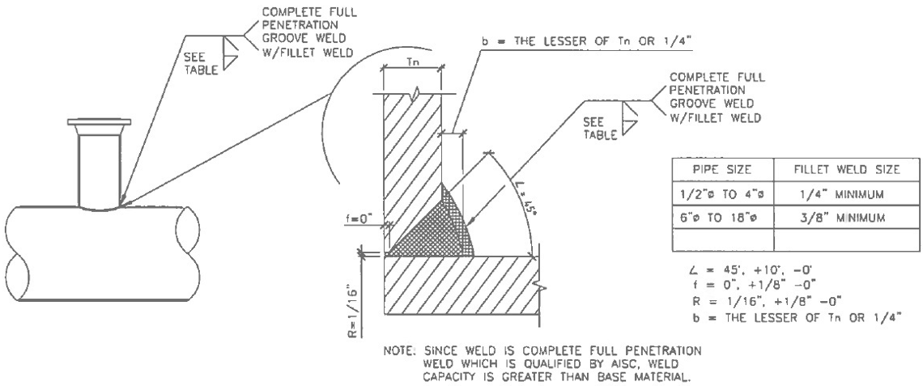
        - Design Basis: ​<< ASME B31.1; ASME B31.3; ASME B31.5; ASME B31.8; and ASME B31.9>>​
        - Is reinforcement required: ​​​<< Yes; or No>>​​​
          - Reinforcement details provided ​​<< on Drawing _______; or below>>​​.
          - ​​<< ______>>​​
Pipe Size (inches) | Fillet Weld Size (inches)
Hidden Paragraph
​​<< 1/2 to 4>>​​ | ​​<< 1/4 minimum>>​​
Hidden Paragraph
​​<< 6 to 18>>​​ | ​​<< 3/8 minimum>>​​
Hidden Paragraph
​​<< ______>>​​ | ​​<< ___>>​​

***************************************************************************************

The following table provides examples of acceptable fillet weld throat thickness for MSS SP-97 integrally reinforced branch connection fittings. The Designer is responsible for calling out fillet weld throat thicknesses that are applicable to the pipe size(s) used in the project.
Branch Pipe IPS | Identification/  Schedule | Branch Pipe Nominal⁽¹⁾ Thickness (Tbar_{b}) | 0.7 x (Tbar b) | Fillet weld throat thickness (t_{c}) | Maximum Run IPS
½ | STD | 0.190 | 0.0763 | 0.0763 | 2
½ | Extra Strong | 0.147 | 0.1029 | 0.1029 | 2
½ | Schedule 160 | 0.188 | 0.1316 | 0.1316 | 2
2 | STD | 0.154 | 0.1078 | 0.1078 | 8
2 | Extra Strong | 0.218 | 0.1526 | 0.1526 | 8
2 | Schedule 160 | 0.344 | 0.2408 | 0.2408 | 8
2 | Extra Extra Strong | 0.436 | 0.3052 | 0.25 | 8

(1) Thickness from ASME B36.10M–2004, Welded and Seamless Wrought Steel Pipe

Table Notes

1. Branch size must not exceed NPS 2 (DN-50)

2. Branch size does not exceed one fourth (1/4; 0.25) the nominal size of the run

3. Minimum wall thickness of the coupling shall not be less than that of the unthreaded branch pipe

4. Coupling or half coupling minimum Class 3000 per ASME B16.11

5. Coupling shall be full penetration groove weld with fillet weld cap

6. Cover fillet weld shall provide a smooth transition to the run pipe with an equal leg fillet at the longitudinal section to an equal leg fillet, unequal (oblique) leg fillet

***************************************************************************************
      - Integrally Reinforced Branch Connection <<MSS SP 97>> Fittings

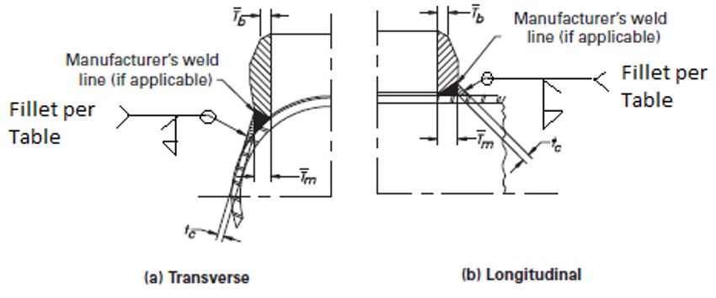
Branch Pipe IPS | Fillet Weld Throat Thickness (T_{C}), Inches
Hidden Paragraph
​​​<< ______>>​​​ | ​​​<< ___>>​​​
Hidden Paragraph
​​​<< ______>>​​​ | ​​​<< ___>>​​​
Hidden Paragraph
​​​<< ______>>​​​ | ​​​<< ___>>​​​
Hidden Paragraph
​​​<< ______>>​​​ | ​​​<< ___>>​​​

Appendix B - Socket and slip-on flange fillet weld sizes

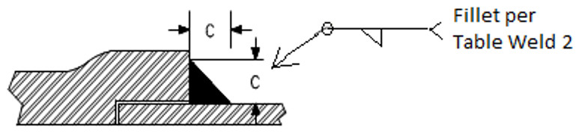

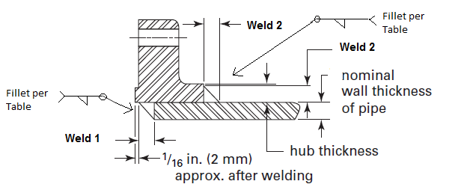

***************************************************************************************

ASME B31.1, B31.3, B31.5, and B31.9 Slip-On Flange Weld Size Determination Method

(Minimum weld dimensions for double-welded, slip-on, socket-weld flange attachment welds)

Reference:

- ASME B31.1 Figure 127.4.4 (B) (a)

- ASME B31.3 Figure 328.5.2 B (1)

- ASME B31.5 Figure 527.3.3-2 (first figure)

- ASME B31.9 Figure 927.4.3-2

Material: ASTM A312/A312M TP304L, UNS S30403

Flange: ASTM B16.5 Class 150

Pipe Size: 1 inch pipe thicknesses per ASME B36.10 (example used for illustration)
One Inch Pipe
Nominal Wall  Thickness  (inch) | Schedule | Standard
0.065 | 5
0.109 | 10
0.114 | 30
0.133 | 40 | Standard
0.179 | 80 | XS
0.25 | 160
0.358 |  | XXS

ASME B16.5 Class 150 Dimensions from Table II-8

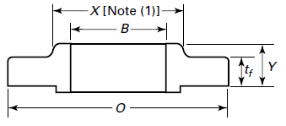

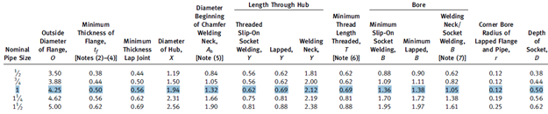

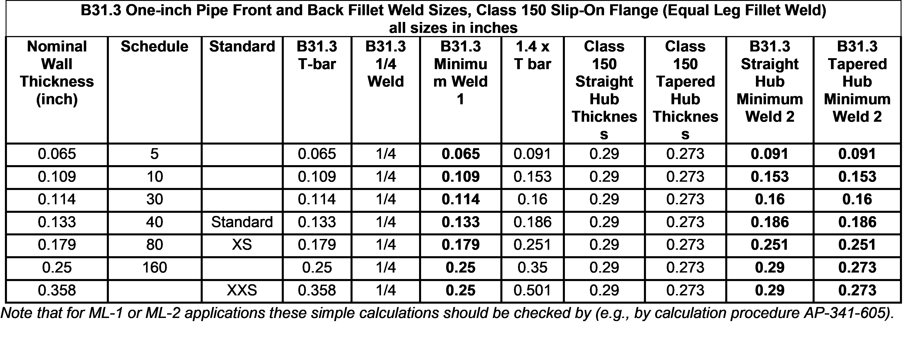

The Designer may specify minimum weld thicknesses in the table below. Retain as many rows and add new rows as needed.

Show weld sizes in fractions (round up)

***************************************************************************************
Pipe/Tube Nominal Wall thickness | Pipe size (schedule/standard) | Weld 1 minimum (inches) | Weld 2 minimum (inches)
Hidden Paragraph
​​​​<< ____>>​​​​ | ​​​​<< schedule 5; schedule 10; schedule 30; schedule 40; schedule 80; schedule 160; standard; XS; XXS; Tubing; or ______>>​​​​ | ​​​​<< 1/4>>​​​​ | ​​​<< 1/4>>​​​​​
Hidden Paragraph
​​<< _______>>​​ | ​​<< schedule 5; schedule 10; schedule 30; schedule 40; schedule 80; schedule 160; standard; XS; XXS; Tubing; or _______>>​​ | ​​<< N/A>>​​ | ​​<< 3/8>>​​
Hidden Paragraph
​<< _______>>​ | ​<< schedule 5; schedule 10; schedule 30; schedule 40; schedule 80; schedule 160; standard; XS; XXS; Tubing; or _______>>​ | ​<< _______>>​ | ​<< _______>>​
Hidden Paragraph
​<< _______>>​ | << schedule 5; schedule 10; schedule 30; schedule 40; schedule 80; schedule 160; standard; XS; XXS; Tubing; or _______>> | ​<< _______>>​ | ​<< _______>>​
Hidden Paragraph
​<< _______>>​ | ​<< schedule 5; schedule 10; schedule 30; schedule 40; schedule 80; schedule 160; standard; XS; XXS; Tubing; or _______>>​ | ​<< _______>>​ | ​<< _______>>​
END OF SECTION

