SECTION 01 4455
ONSITE WELDING & JOINING REQUIREMENTS
*********************************************************************************************************************
LANL MASTER SPECIFICATION

New in this revision: Appendix A flowchart; submittals clarified, including that they be sent with the Div 02-50 Section to which they pertain; clarified inspection requirements.

Template available online at http://engstandards.lanl.gov/specs.shtml

In Word, VIEW HIDDEN TEXT TO SEE blue Authors notes
This Section includes administrative and procedural requirements for welding activities. It is designed to be used in conjunction with other LANL specifications that invoke project specific requirements as well as applicable codes & standards for welding.
This template must be edited for each project. In doing so, specifier must add job-specific requirements. Brackets are used in the text to indicate designer choices or locations where text must be supplied by the designer. Once the choice is made or text supplied, remove the brackets. The specifications must also be edited to delete specification requirements for processes, items, or designs that are not included in the project -- and specifier’s notes such as these. To seek a variance from requirements in the specifications that are applicable, contact the Engineering Standards Manual (ESM) Welding POC. Please contact POC with suggestions for improvement as well.
When assembling a specification package, include applicable specifications from all Divisions, especially Division 1, General requirements.
Specification suitable for ML-1 through ML-4 projects.
*********************************************************************************************************************
Verify that Section titles referenced in this Section are correct for this Project's Specifications; Section titles may have changed.
- GENERAL
      - SUMMARY
        - This Section includes requirements for welding and joining on the LANL site as required by other sections of the Specification, consensus codes and standards, and/or engineering design. See Appendix A of this section for onsite welding overview.
        - Pressure-retaining code-stamped items shall only be welded on by organizations with the applicable ASME or National Board Certificate(s) of Authorization. Certificate holders are organizations that have been authorized by the ASME and/or The National Board to perform various activities in accordance with the requirements of the ASME Boiler and Pressure Vessel Code and/or The National Board.
        - Offsite welding shall be in accordance with design documents, applicable codes & standards, and Section 01 4444 on same.
      - SUBMITTALS
        - The following documents shall be submitted and approved by LANL Welding Program SME prior to the start of welding. Submit per 01 3300 procedures. Do not submit with reference to this Section (01 4455), but rather to each and every Div 02–50 section to which they apply. These are discussed in greater detail later in this Section.
          - Welding/Brazing/Bonding Procedure Specifications with the associated Procedure Qualification Records (PQRs)
          - Welder/Brazer/Bonder Performance Qualification Records (WPQR) and continuity logs/statement if welding certifications are greater than six months old.
          - Weld Filler Material Control Procedure for high risk applications
          - Filler Material Certified Material Test Reports (CMTRs) for high risk applications
          - Post-Weld Heat Treatment Procedures (where applicable)
          - Inspector qualification records
          - Inspection procedures where required by code or Specification.
          - Inspection reports and weld maps.
      - Welding Checklist – A Welding Checklist shall be completed prior to onsite welding to assure that the specific requirements for welding activities have been identified and addressed. Welding Checklist shall be signed by a LANL CWI. The Welding Checklist can be found at:
http://www.lanl.gov/orgs/eng/engstandards/ESM_Ch13.shtml#checklist

*************************************************************************************************************

Delete Design article when design is provided to welding entity. When all welding is to a code, delete second half of design article regarding non-code equivalent work.

*************************************************************************************************************
      - Design - Design of welded structures, systems and components (SSC) shall meet the requirements of LANL ESM and as a minimum identify applicable codes and standards including requirements of graded application. For welding activities that would normally fall outside the defined scope of specified national consensus codes and standards for fabrication and welding, such codes and standards shall be adopted and used to the extent possible.

*********************************************************************************************************

Note- Numerous codes & standards define graded approaches which specify multiple levels of welding requirements. Designs which specify the codes & standards listed below shall also specify service or category and applicable welding requirements these codes identify:
      - ASME B31.1 – Material, Temperature, & Pressure
      - ASME B31.3 – Service Categories, D, Normal, M, & High Pressure
      - ASME B31.5 – Safety Group A3 & B3
      - 49 CFR Part 192 -- Class, location
      - AWS D1.1 – Static, Cyclic, and Tubular Structures
      - AWS D1.6 – Static, Cyclic

**********************************************************************************************************
        - Engineering drawings shall specify all fillet weld sizes and partial penetration weld sizes.
        - Shop drawings shall show weld symbols and requirements to define the work and enable design review and inspection this shall include fillet weld sizes and partial penetration weld sizes.
        - Applications that are not similar in materials or processes to a specified code or standard shall define and produce the following:
          - Design basis; i.e., mechanical properties, part geometry, acceptance criteria.
          - A method to verify that the welding procedure can produce acceptable welds
          - A method to demonstrate that the welder has the skill to produce sound welds in accordance with the specified welding procedure (reference GWS 1-02, Administrative Control of Welding and Brazing, para 5.3.B)
          - Identify methods and perform inspections, required to judge welds against predetermined acceptance criteria.
          - Provide documentation that these objectives have been defined and identified.
      - Qualified Procedures – Welding and brazing shall be performed in accordance with LANL-approved welding/brazing procedure specifications (WPS/BPS) that have been qualified in accordance with applicable codes and standards or design criteria:
        - LANL welding/brazing procedure specifications may be used with LANL permission and are located at: http://engstandards.lanl.gov/ESM_Ch13_specs.shtml
        - AWS Standard Welding Procedure Specifications and written Prequalified Welding Procedure Specifications as allowed by applicable codes and standards may also be used if approved by the LANL Welding Program Administrator.
        - Heat treating as required.
      - Joining (solvent bonding, adhesive, and electro-fusion joints): When required by consensus codes and standards (e.g., ASME B31.3 & 49 CFR Part 192), joining shall be done by LANL-qualified personnel following LANL-approved procedures.
      - Certified Personnel - Welding and brazing shall be performed by welders and brazers who have demonstrated their welding/brazing skill by test at LANL and are LANL-certified.
        - Current listing located at http://eswebserver.lanl.gov/welding/engstandard.aspx (LANL access only)
        - WPQR: Welder/brazer/bonder performance qualification records are in database, as is welder continuity tracking.
      - Procurement & Control of Consumables - Subcontractors are responsible to supply filler material meeting the requirements defined in GWS 1-03 and attachments unless filler material is to be government-furnished by contract. On a case-by-case basis as authorized by the responsible Subcontractor’s STR, LANL-stocked filler material may be issued. If LANL stock materials are issued to a Subcontractor then the cost of those filler materials will be charged to the LANL project. The Subcontract STR should require compensation from the subcontractor for the cost of filler materials. LANL will disburse daily quantities to those with proper paperwork (STR approval, Welding Checklist, and Weld Material Request); they will also issue bulk quantities to those maintaining WPA-approved satellite and issue stations (LANL-only link). A list of stocked filler material is here.
        - The procedure for procurement, storage, issue and control of consumables is found in ESM, Chapter 13 Welding & Joining, Volume 1, General Welding Standard (GWS) 1-03. Filler material shall be procured with Certified Material Test Reports (CMTRs) traceable by heat/lot number.
          - Certified Material Test Reports (CMTRs) shall meet the requirements of AWS A5.XX Standards for Welding Filler Materials. Reports shall detail physical and chemical properties of the material(s) and be in accordance with the applicable national or international material standards (e.g., ASTM, ASME) for the material type. CMTRs must be the results of test performed by the material manufacturer or by a material verification process, if such a process is allowed by the standard governing the material type, and must specify the test method and the source of the acceptance criteria. Each CMTR must be signed by an authorized representative of the testing entity, be traceable to the materials delivered via heat, lot, or other identification, and must meet any content requirements of the applicable national or international standards invoked for the material type.
          - Structures, systems and components (SSC) which are designated ML-1, ML-2, safety class, or safety significant shall have CMTRs for welding consumables that are traceable by heat/lot # to the weld in which they were consumed.
        - Filler materials shall be issued from approved locations by authorized personnel to qualified welders.
          - WPA-approved satellite and issue stations (LANL-only link)
      - Welding inspection - shall be performed by qualified personnel in accordance with applicable consensus codes and standards and as specified in the design documents.

*************************************************************************************************************

Caution - Numerous codes & standards define two levels of inspection. Examples of this are AWS D1.1 & AWS D1.6, ASME B31.1 & B31.3

Construction or fabrications which are designed to these codes shall be coordinated between the subcontractor/fabricator and LANL Project Team for the required OWNER Inspection of in-process and final welding inspections.

Note: LANL Project Team may assign LANL to perform both construction/fabrication & owners inspections.

************************************************************************************************************
        - Inspector Qualification/Certification – Welding inspectors are required to be approved by LANL WPA or a LANL Level III to perform visual and NDE inspection/examinations. This involves acceptance of inspector qualification records. If approvals are not current, Subcontractor shall resubmit.
        - Welding Inspections required by consensus codes and standards or design shall be documented. Welding inspection reports shall identify at least the following:
            - Method, type, date, and extent of Inspection or test
            - Acceptance/rejection as based on the criteria specified by the design documents; reference to information on action taken in connection with nonconformances.
            - Code or standard used for acceptance and class, category, or service
            - Record attributes inspected and severity
            - Identification and location of welds inspected including weld maps
            - M&TE – Identification and date of calibration expiration for measuring and test equipment used
            - Name, date, and signature of person who performed the inspection
            - Inspector’s qualification level
        - Inspection Procedures - When inspection procedures are required by the referenced code & standards, procedures shall be reviewed and approved by a LANL Level III inspector in the applicable inspection method
            - NDE Procedure Qualification Records - When inspection procedures are required to be qualified by the referenced code & standard, procedure qualification records will be reviewed and approved by a LANL Level III inspector in the applicable inspection method.
        - Inspection results, including weld maps, shall be documented and provided to LANL within one day after completion of associated inspection work.
        - When applicable codes and standards specify two levels of inspection, LANL will perform the higher level. The qualification of the Owners Inspector and inspections will be done by LANL personnel as specified in ESM, Chapter 13, Volume 1, GWS 1-02 (Para. 5.9 in r7); see: http://engstandards.lanl.gov/ESM_Ch13.shtml#ch13_vol1
        - LANL may elect to have its own qualified inspectors and personnel present during all welding activities for oversight.
          - At least five-working-days’ notice is required prior to inspection & testing activities planned by the fabricator so that LANL can arrange for its staff’s participation.
          - Hold Points may be identified in the construction/fabrication schedule to allow for LANL’s inspection activities.
      - Subcontracted Welding
        - Subcontracted welding activities shall have all Specifications and Drawings and their applicable requirements flowed down to any sub-tier who is to perform those welding activities.
        - Requirements for subcontracted welding shall be identified in Sub-tier Subcontract documents as outlined in GWS 1-09, Control of Subcontracted Welding.
      - RECORDS
        - The following documents shall be collected and maintained in the project files:
Project Record Item | 01 4455 Reference
- Welding/brazing/bonding procedure specifications used (e.g., LANL WPS/BPS) | 1.5
- Welder/brazer/bonder performance qualification records (WPQR) | 1.7
- Weld Material Requests (yellow copy) | 1.8
- Inspector qualification records | 1.9.A
- Inspection reports including weld maps | 1.9.B, D
- Inspection procedures | 1.9.C
- For nuclear safety and similar projects (ML-1, ML-2, safety class, and safety significant SSCs), CMTRs of filler material traceable to weld in which consumed | 1.8.A
- Heat treatment charts or records as required | 1.5.C

PART 2 PRODUCTS

Not Used

PART 3 EXECUTION

Not Used

Appendix A

Onsite Welding Flowchart

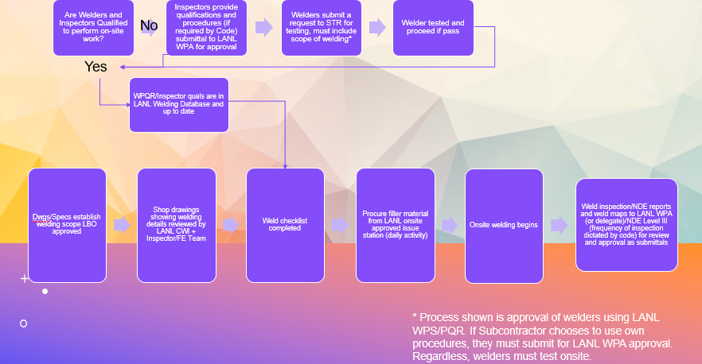

END OF SECTION

************************************************************
Do not delete the following reference information:
************************************************************

THE FOLLOWING STATEMENT IS FOR LANL USE ONLY
This project specification section is based on LANL Master Specification Section 01 4455 Rev. 3, dated May 24, 2021.

