SECTION 01 4731
FLANGE ASSEMBLY for B31 Systems
******************************************************************************************************************
LANL MASTER SPECIFICATION SECTION — OR INPUT To ELSEWHERE

Word file at https://engstandards.lanl.gov
Rev. 1 Summary of Changes
Clarified intent, added option to move content to Drawings or Div 02-48 (wherein submittals are to be sent), updated code editions and other references.

This is not a typical LANL master. It is verbiage and examples of flanged-joint design/fab final design that the Design Agency must convey to the Constructor/fabricator. Conveying this can be accomplished in several ways:

Option 1: Including (distributing out) the applicable material into each Div 02-48 Section that involves this work (in which case delete ALL references to this Section in Spec Book).

Option 2: Including applicable material herein on the Drawings. (in which case delete ALL references to this Section in Spec Book).

Option 3: Include this Section in the Specification while making clear that the submittals discussed here are always sent in per the affected Div 02-48 Section (Option 3 is the last and least desirable option).

This document captures LANL’s B31 flanging requirements once (rather than in multiple sections) for LANL’s convenience in maintaining the requirements. It is provided as an aid to the Design Agency for providing a complete, code-compliant design that LANL can review and accept during the design phase. Delegation and deferment of said design requires LANL Project Engineer and Pressure Safety SME prior approval.

This section potentially affects (but is not limited to) the following related LANL Masters:
22 1500, Compressed Air Systems (nominally B31.9),
23 2113, Hydronic Piping (B31.9),
23 2215, Steam and Condensate Heating Piping and Specialties (nominally B31.9)
23 2300, Refrigerant Piping (B31.5), and
40 0504, Process Piping (B31.3).
This template was developed to meet the requirements for ASME B31.3-2020, Fluid Service Category D and Normal, except for oxygen and cryogenic service. Application of this template to a different fluid service or edition of B31.3 will require a detailed review of the code and ESM Chapter 17. If other B31 codes are involved, the Code of Record the Designer is responsible updating this document as required by the Code of Record.
The designer is encouraged to read and apply ASME B16.5 and ASME PCC-1.
The designer is encouraged to review the DOE Handbook DOE-HDBK-1132, Design Considerations, and the LANL Engineering Standards Manual Chapters 13 and 17.
This template material must be edited for each project. In doing so, specifier must add job-specific requirements. Brackets are used in the text to indicate designer choices or locations where text must be supplied by the designer. Once the choice is made or text supplied, remove the brackets. This section must also be edited to delete requirements for processes, items, or designs that are not included in the project -- and specifier’s notes such as these.
Please contact POC with suggestions for improvements.

When assembling a specification package, include applicable Sections from all Divisions, especially Division 01, General requirements.

This Section material was developed for ML-4 projects. For ML-1, 2, and 3 applications, additional requirements might be necessary if increased confidence in procurement or execution is desired, and independent review is necessary. See ESM Chapter 1 Section Z10 specifications and quality sections.

******************************************************************************************************************
Part 1 GENERAL
  - Section Includes

General requirements for flange assembly.

******************************************************************************************************************

See ASME B31.3, Appendix M, Fig. M300 for classifying fluid services for fluids not listed.

******************************************************************************************************************
  - rELATED sECTIONS
      - Section 01 4216, Definitions
******************************************************************************************************************
In the listing below, designer must eliminate standards that are not applicable to the project and add standards that are applicable. Then, designer must either (1) specify each B31.9-listed materials’ national standard edition for each remaining standard listed or (2) determine latest is equivalent. Then modify to either (1) implement the first option—and also list the edition year after each standard number (e.g., ASTM F493-04)—or (2) implement the second option.
******************************************************************************************************************
  - References
    - Abbreviations and Acronyms
Term | Meaning
SBR | styrene-butadiene rubber (gasket)
SWG | spiral-wound gasket
    - Reference Standards
The code of record for this installation is as follows: ASME B31.3 – [2020], Process Piping.
**********************************************************************************************************
Only the standards most widely or uniquely used at LANL applications are listed below; add others that are relevant to the design, where this will be helpful to users.
**********************************************************************************************************
ASME
- ASME B1.1, Unified Inch Screw Threads (UN and UNR Thread Form)
- ASME B16.5, Pipe Flanges and Flanged Fittings NPS 1/2 Through NPS 24
- ASME B16.20, Metallic Gaskets for Pipe Flanged Ring Joint, Spiral Wound and Jacketed
- [ASME B16.1, Gray Iron Pipe Flanges and Flanged Fittings, Classes 25, 125, and 250]
- ASME B16.21, Nonmetallic Flat Gaskets for Pipe Flanges
- [ASME B16.42, Ductile Iron Pipe Flanges and Flanged Fittings]
- [ASME B16.47, Large Diameter Steel Flanges NPS 26 Through NPS 60]
- ASME B18.2.1, Square, Hex, Heavy Hex, and Askew Head Bolts and Hex, Heavy Hex, Hex Flange, Lobed Head, and Lag Screws (Inch Series)
- ASME B18.2.2, Nuts for General Applications: Machine Screw Nuts, Hex, Square, Hex Flange, and Coupling Nuts (Inch Series)
- ASME BPV Code, Section V, Nondestructive Examination
- ASME PCC-1, Guidelines for Pressure Boundary Bolted Flange Joint Assembly
ASTM International
  - ASTM A193, Standard Specification for Alloy-Steel and Stainless Steel Bolting for High Temperature or High Pressure Service and Other Special Purpose Applications
  - ASTM A194, Standard Specification for Carbon Steel, Alloy Steel Nuts, and Stainless Steel Nuts for Bolts for High Pressure or High Temperature Service, or Both
  - ASTM A182, Standard Specification for Forged or Rolled Alloy and Stainless Steel Pipe Flanges, Forged Fittings, and Valves and Parts for High-Temperature Service
  - [ASTM A395/A 395M, Standard Specification for Ferritic Ductile Iron Pressure-Retaining Castings for Use at Elevated Temperatures (not listed, not pressure boundary)]
  - ASTM F436/F436M, Standard Specification for Hardened Steel Washers (not listed, not pressure boundary)

ACTION Submittals
Submittals shall be in accordance with Section 01 3300.
    - Before fabrication, submit NDE (non-destructive examination) procedures that will be used for fabrication and examination of the piping, and pressure-leak testing and cleaning procedures.
    - Prior to receiving materials, submit the Material Control Procedure.
    - Provide all submittals required by Section 01 4115, Pressure Safety Submittals, for the as-constructed configuration.

Quality Assurance
- Material Control Procedure
      - Work shall be performed in accordance with a LANL-approved Material Control Procedure. This procedure shall describe the control methods and documentation used to handle and monitor the use of controlled materials (piping component, fasteners, and welding filler rod and other components).
      - The procedure shall follow manufacturer’s requirements for storage and handling.
      - The procedure shall also address procurement controls, segregation of materials, and traceability of materials from receipt at the shop through processing and final assembly.
- Inspection and Testing
      - The Subcontractor shall perform inspection and testing to verify the conformance to the specified requirements defined in Part 2 of this Section, as well as any Subcontractor requirements as defined as part of the Subcontractor’s QA/QC program.
      - The Subcontractor shall provide an Inspection and Test Plan indicating all testing and inspection functions to be performed, including hold points during fabrication and assembly, as well as during the factory acceptance testing (FAT).
      - All inspection and testing functions shall be performed by qualified personnel using qualified procedures in accordance with specified requirements.
      - Hold points are required during the fabrication process to allow inspection, verification, or approval by LANL before the Subcontractor does further work. Hold points shall be identified on the Inspection and Test Plan, with provisions for LANL review and acceptance. LANL has the right to waive Hold Points at their discretion.
      - Inspection Records: The Subcontractor shall appropriately record, submit and maintain records documenting the inspection and/or test then submit the completed Inspection Record as part of the QA Document Package. The status of all planned and executed inspection and testing activities shall be logged and traceable to ensure that the required inspection and testing have been performed, and any items that have failed inspection or testing are not inadvertently installed or implemented.
- Qualifications
      - Qualification of Examination Personnel:
- Certified Welding Inspectors (CWI) shall be in accordance with Sections 01 4444 (offsite welding) and/or 01 4455 (onsite welding) as applicable.
- Personnel performing other examination shall be certified in accordance with Subcontractor’s written practice. Personnel performing nondestructive examination to the requirements of [B31.3, B31.5, B31.9] shall be qualified and certified for the method to be utilized following a procedure as described in the ASME BPV Code, Section V, and Article 1, T-120 (e) or (f).
- Certifications of examination personnel shall be maintained for Inspector’s review.
- Examination records including examiner’s qualifications and procedures shall be retained for at least 5 years.
      - Owner’s Inspector shall be qualified in accordance with ASME [B31.3, B31.5, B31.9] and LANL’s Construction Management group (PIO-CM) procedures. LANL shall act for DOE to designate Owner’s Inspectors or Representatives.
      - Subcontractor Qualifications
        - Have a minimum of 5 years of experience in B31 construction.
        - [Have maintenance service based within 200 miles radius of installation.]
******************************************************************************************************************
Designer notes
- Gasket materials shall be compatible with the fluids and service conditions.
- Fasteners are to be in accordance with ASME B1.1 UNS Classes 1A (external) and 1B (internal) uncoated unless otherwise specified.
- Bolt and nut material grades shall be in compliance with the ASME B16.5 Table 1B recommendations (see Appendix A of this section)
- Comply with B16.20 for metallic gaskets, and B16.21 for non-metallic gaskets
- Flange surface finish (roughness) shall be compatible with the gasket material. Soft gaskets such as neoprene should have a rough finish (e.g., 250AA) and flat metal gaskets should have a smoother finish (e.g., 32AA); see ASME PCC-1 Table C-1.
- Specified fasteners must comply with the recommendations of ASME B16.5 and gasket type.
- Fasteners shall be segregated to ensure the correct fastener is used on the correct application.
- Torque requirements for flange connections shall be in accordance with the gasket manufacturer’s torque requirements and the recommendations of ASME B16.5.
- Gaskets shall be segregated to ensure the correct gasket is used on the correct application.
******************************************************************************************************************
Part 2 PRODUCTS
  - product options and substitutions
    - Alternate products may be accepted per Section 01 2500.
    - Flange Joint
      - Flange:
        - Fluid Service: [Category D, Category Normal]
        - Fluid: hydronics [RLW, glycol]
        - Material Group: 2.3
        - Material: A182 Gr. F316L
        - Class: 150
        - Size: 4 inch
        - Type: full face [raised face, ring joint] [serrated concentric, serrated spiral finish]
        - Flange finish (Ra): 250 micro inches (general use with flange gasket spiral-wound, corrugated metal jacket with corrugated metal core, grooved metal gasket with facing layer such as graphite or PTFE) [dangerous and gases 125 micro inches]
        - Flange circumferential flatness: variation less than [0.006 in hard gasket, 0.01 in soft gasket]
        - Flange radial flatness: variation less than [0.006 in hard gasket, 0.01 in soft gasket
****************************************************************************************************************
For heat exchanger-type application, define the maximum acceptable pass-partition surface height versus flange face; see ASME PCC-1 Table D-1.
****************************************************************************************************************
        - Manufacturer: FNW
        - Part Number: FNW B7 D052 L0350
****************************************************************************************************************
Fasteners shall comply with ASME B16.5, Table 1B–List of Bolting Specifications and Table 1C–Flange Bolt Dimensional Requirements.
ASME B16.5 Table 1B is repeated in Appendix A
****************************************************************************************************************
      - Externally threaded fasteners
        - Threads: ASME B18.2.1, UNS Class 2A, Right Hand, Course, heavy hex head [square or heavy hex head for carbon steel, heavy hex head for alloy steel]
        - Material Specification: A 193
        - Grade: B7 (high strength)
        - Size: 5/8 inch diameter x 3.5 inch long stud bolt (minimum) [5/8 bolt diameter 3.00 minimum length machine bolt) [size, length]
        - Type: ASME B18.2.1, heavy hex head [square head]
        - Thread: ASME B1.1 2A Coarse [>1 inch eight thread series]
        - Plating: none (light oil coat)
        - Quantity per Flange: 8 [4, 6, 8, 12, 16, 20, 24]
        - Manufacturer: FNW
        - Part Number: FNW B7 D052 L0350
      - Internally threaded fasteners
        - Threads: ASME B18.2.2, UNS Class 2B, Right Hand, Course, heavy hex [heavy hex carbon steel smaller than ¾, heavy hex or hex carbon steel carbon steel ¾ inch and larger, heavy hex alloy steel] [2B coarse carbon steel, 2B course alloy steel up through 1 inch; eight thread series for larger bolts]
        - Material Specifications: A 194
        - Grade: 2H (high strength)
        - Size: 5/8 inch
        - Type: ASME B18.2.2, heavy hex head [square head]
        - Thread: ASME B1.1 2B Coarse [>1 inch eight thread series]
        - Plating: none (light oil coat)
        - Quantity per Flange: 8
        - Manufacturer: FNW
        - Part Number: FNW A194 H2
      - Washers
        - Material Specifications: ASTM F436
        - Material Type: 3 (weathering steel) through-hardened, surface HRC 38 to 45, minimum core HRC 30.
        - Style: Circular
        - Size: 5/8 inch
        - Plating: none (light oil coat)
        - Quantity per Flange: 16
        - Manufacturer: FNW
        - Part Number: FNW A194 H2
      - Metallic Gaskets
        - Fluid Service: Category Normal [Category D]
        - Fluid: RLW [Compressed Gas less than 150 psig]
        - Specification: ASME B16.20
        - Type: Spiral-Wound Gaskets (SWG) 316ss, flexible graphite filter GRAFLEX®, green edge denoting 316.
        - Pressure Rating: per B16.5
        - Temperature Rating: 32 to 842 deg F
        - Size: 4 inch flange, 1/8 inch thickness
        - Manufacturer: FNW
        - Part Number: FNW SWG 150#6fp
      - Non-Metallic Gaskets
        - Fluid Service: Category D [Category Normal]
        - Fluid: Compressed Nitrogen Gas less than 150 psig [RLW]
        - Specification: ASME B16.21
        - Type: Red Rubber Gaskets; Styrene-Butadiene (SRB), 75 Shore A +/- 5.
        - Pressure Rating: 200 psig
        - Temperature Rating: -20 to 170 deg F
        - Size: 4-inch flange, 1/8 inch thickness
        - Manufacturer: FNW
        - Part Number: FNW R 1FFGAP
      - Electrical isolation kit
        - Fluid Service: Category D
        - Size: 4-inch flange, 1/8 inch thickness
        - Application: [full face flange, raised faced flange, ring flange]
        - Gasket Type: [E, F, D (matches flange type above respectively)]
        - Gasket Sealing Element, Sleeve, and Washer Material: None, black polyethylene plastic, black polyethylene plastic
        - Manufacturer: M&P, Flange and Pipe Protection, Inc.
      - Fastener Assembly Lubricant
        - Stainless steel
          - Rocol Accu-Lube 14143 (low or no halide content)
          - Supplier: Aviall Services INC, Dallas, TX 1-800-284-2551
        - [Carbon steel
          - Loctite 51606 C-100 Anti-Seize Lubricant
          - Supplier: Diamond Tool, 888-879-3426]
      - Gasket Spray Adhesive
          - 3M Hi-Strength 90 Spray Adhesive
          - Supplier: Home Depot or similar.
PART 3 EXECUTION
- GENERAL NOTES
    - Piping (and tubing) Systems: Fabricate, inspect, examine, and test in accordance with ASME [B31.3, 31.5, 31.9].
    - Remove scale, slag, dirt, and debris from inside and outside of piping components.
- PREPARATION
******************************************************************************************************************
Review ESM Chapter 17 ADMIN-2 Design, Documentation, and Records, for information on cleaning
******************************************************************************************************************
    - Pipe Cleaning
      - Piping shall be cleaned in accordance with [define required cleaning process] and meet the cleaning specified requirement [define the state of the item after cleaning: particulate size and counts, amount and type of non-volatile residue, unacceptable or acceptable chemical residue, or biologically sterile]
      - Subcontractor shall be responsible for the cleanliness and integrity of the system. Pipe, tube, and components shall be free of dirt, paint, metal chips, filings, flux, slag, weld spatter, scale, rust, grease, oil, waxes, or other contaminants that are easily seen with the unaided eye.
      - Consult Manufacturer’s recommendation for the use of acids and cleaning agents to prevent damage. Cleaning agents used with stainless steel systems shall contain no more than 50 ppm halide content.
      - Ensure safeguards are taken to protect personnel from hazards of cleaning, which may include but not be limited to flying particulates, corrosive chemicals, and harmful vapors.
      - A suitable chemical or mechanical cleaning method shall be used, if necessary, to clean all surfaces to be fabricated.
      - All surfaces shall be clean and free from paint, oil, rust, scale, and any other potentially detrimental material.
      - A soft wire brush of the same material type as the flange is required. For example, austenitic stainless steel brushes are required for F316L flanges.
- FABRICATION
******************************************************************************************************************
- Other, more accurate, methods of obtaining preload such as bolt tensioners or measurement of bolt elongation may be substituted for torque wrenches if performed in accordance with an approved procedure.
- The proper lubricant shall be used on threads of bolts and nuts. Consult the manufacturer for the recommended lubricant; see paragraphs 3.5 B.2 and 3.
- Where a metallic flange is bolted to a nonmetallic flange, both shall be flat faced. The use of a gasket between these two flanges is not mandatory unless specified by the manufacturer. For nonmetallic flanges bolting torque shall be based on the manufacturer’s recommendations and limited so that the nonmetallic flange is not overloaded. Backup flanges may be necessary for the nonmetallic flange; ASTM A395/A 395M, Standard Specification for Ferritic Ductile Iron Pressure-Retaining Castings for Use at Elevated Temperatures.
- Use hardened-steel washers and/or lubricate smooth face of nut (i.e., face under compression load). Raised lettering on the nuts must be faced outward.

- After leak test and system startup, thermal expansion, creep relaxation, and fastener thread embedment can change the fasteners’ applied load. Re-torque after 48 hours is recommended. Therefore, a re-check of each fastener is recommended especially for piping systems that have non-metallic gaskets and operate at temperature levels above 200 F.
******************************************************************************************************************
    - All piping shall be fabricated in accordance with provided Construction Drawings.
    - No pipe or tube bends are allowed. Fittings are to be used instead of bends.
******************************************************************************************************************
If pipe bends are to be allowed, calculations must be done to determine the wall thickness of the bend on the inside and outside of the bend. This value must be compared to the piping in the as-formed condition. The NDE procedures to check the bends must be submitted as an Action Submittal.
******************************************************************************************************************
    - Material Control
      - Segregation of carbon steel and stainless steel shall be maintained throughout fabrication.
- EXAMINATION, TESTING, AND INSPECTION
    - Special Instructions
      - All piping joints connecting to existing piping are to be leak tested in accordance with LANL Engineering Standards Manual STD-342-100 Chapter 17 Section EXIST–Legacy System Requirements, ”Modification or Maintenance of an Existing System” subsection (3.0).
    - For the purposes of this section, the Subcontractor is responsible for all tasks identified as examination and testing. CWI activities are considered examination. Owner’s Inspector activities are considered inspection.
    - Examination
      - Both the extent of examination and acceptance criteria shall be in accordance with ASME [B31.3, B31.5, B31.9] (for example paragraph 341 Examination and/or, for non-metallic systems, Section A341 as applicable.)
        - When pneumatic leak testing is planned, 100% of all threaded, bolted, and other mechanical joints shall be examined during assembly.
    - Inspection
      - Owner’s Inspector shall have access to any and all design, fabrication, manufacture, fabrication, heat treatment, assembly, erection, examination, testing, records, documentation, or other project information or activities to verify that all required examinations and testing have been completed and to inspect the piping to the extent necessary to be satisfied that it conforms to all applicable examination requirements of the Code and of the engineering design and to perform the role defined in ASME B31.3.
      - Owner’s Inspector is the final authority on acceptance of the project, examination, or test.
- PRE-ASSEMBLY
    - General
      - Verify materials are correct before assembly in accordance with the accepted Material Control Procedure.
    - Fasteners
      - Fastener materials shall be free of nicks, burrs, chips, dirt, and damage (inspect threads, shank, and nuts). All damaged fasteners must be replaced.
      - For new, coated bolts and nuts, nuts must run freely by hand past where they will come to rest after tightening. If nuts will not turn freely by hand, check for cause and make necessary corrections/replacements. Lubricant application is limited to the second and subsequent tightening operations since the coating provides sufficient lubrication for the first tightening.
      - For non-coated bolts or second and subsequent tightening of all bolts, apply lubricant liberally and completely to the nut contact faces and to the threads on both ends of the bolts past where the nuts will come to rest after tightening; the lubricant should be applied after the bolts are inserted through the flange bolt holes to avoid possible contamination with solid particles that could create unwanted reaction torque.
      - The following Table 1 is based on ASME B16.5 and provides the number of fasteners based on commonly used Class and NPS size. See Appendix B for an example of B16.5 fasteners and required lengths of bolts or studs.

TABLE 1 - Flange Fasteners
NPS | Class 150 |  | Class 300 |  | Class 600
NPS | Bolts¹ | Size | Bolts¹ | Size | Bolts¹ | Size
½ | 4 | ½” | 4 | ½” | 4 | ½”
¾ | 4 | ½” | 4 | 5/8” | 4 | 5/8”
1 | 4 | ½” | 4 | 5/8” | 4 | 5/8”
1 ½ | 4 | ½” | 4 | ¾” | 4 | ¾”
2 | 4 | 5/8” | 8 | 5/8” | 8 | 5/8”
2 ½ | 4 | 5/8” | 8 | ¾” | 8 | ¾”
3 | 4 | 5/8” | 8 | ¾” | 8 | ¾”
4 | 8 | 5/8” | 8 | ¾” | 8 | 7/8”
6 | 8 | ¾” | 12 | ¾” | 12 | 1”
8 | 8 | ¾” | 12 | 7/8” | 12 | 1 1/8”
10 | 12 | 7/8” | 16 | 1” | 16 | 1 ¼”
12 | 12 | 7/8” | 16 | 1 1/8” | 20 | 1 ¼”
14 | 12 | 1” | 20 | 1 1/8” | 20 | 1 3/8”
16 | 16 | 1” | 20 | 1 ¼” | 20 | 1 ½”
18 | 16 | 1 1/8” | 24 | 1 ¼” | 20 | 1 5/8”
20 | 20 | 1 1/8” | 24 | 1 ¼” | 24 | 1 5/8”
24 | 20 | 1 ¼” | 24 | 1 ½” | 24 | 1 7/8”
Notes: 1. “Bolts” refer to the quantity of all types of threaded fasteners used in flange joint assembly (e.g., bolts or studs)
    - Flanges
      - Visually inspect the face surface finish of all flanges for injurious defects. Surface shall be free of any defects, nicks or burrs.
      - Faces (both raised and flat) shall be clean, free of debris or foreign material and degreased. Imperfections such as nicks, dents or gouges will affect the gasket’s ability to seal.
      - All rust and burrs must be removed, and small scratches should be removed by polishing; other defects may mean component replacement.
      - Permissible imperfections in flange surface finish are specified in Table 2.
      - Check raised-face and flat-face flanges for flatness with a straight edge.
******************************************************************************************************************
See ASME PCC-1 Table D-1 for flatness tolerances
******************************************************************************************************************
      - Check the spiral (phonographic) or concentric groove on the face of raised- and flat-face flanges. Any radial defects for example will be virtually impossible to seal against; replace as necessary.
      - Ring-type-joint (RTJ) grooves must be kept scrupulously clean, corrosion free, and undamaged.
      - When cleaning a flange face, never use a tool that may damage the surface finish.
      - Correct out-of-tolerance conditions before the gasket is installed to avoid damaging to the gasket. Only minimum or reasonable adjustments may be made after the gasket is installed.
******************************************************************************************************************
ASME PCC-1 Table D-2 below may be used as an alternative to Table 2 Permissible Imperfections shown below based on ASME B16.5 Table II.
Table D-2 Allowable Defect Depth versus Width Across Face (U.S. Customary)

Measurement | Hard-Faced Gaskets | Soft-Faced Gaskets
r_{d} < w/4 | < 0.030 in. | < 0.050 in.
w/4 < r_{d} < w/2 | < 0.010 in. | < 0.030 in.
w/2 < r_{d} < 3w/4 | Not allowed | < 0.005 in.
r_{d} > 3w/4 | Not allowed | Not allowed
GENERAL NOTE: From ASME PCC-1. See Figs. D-1 Flatness, D-2 Flange Face Imperfections, D-3 Pits and Dents, and D-4 Scratches and Gouges for description of defect measurement.
******************************************************************************************************************

TABLE 2 - Permissible Imperfections in Face Finish
NPS | Maximum Radial Projection of Imperfections Which are No Deeper than the Bottom of the Serrations (in.) | Maximum Depth and Radial Projection of Imperfections Which are Deeper than the Bottom of the Serrations (in.)
½ through 2½ | 0.12 | 0.06
3 | 0.18 | 0.06
4 through 6 | 0.25 | 0.12
8 through 14 | 0.31 | 0.18
16 | 0.38 | 0.18
18 through 24 | 0.50 | 0.25
    - Alignment
      - When aligning requires more force than can be exerted by hand or common hand-and-hammer alignment tools such as spud wrenches and alignment pins, consult the LANL STR.
      - If the flanges in need of aligning are connected to pumps or rotating equipment, great care must be taken to prevent introducing a strain into the equipment housing or bearings. Mark the equipment position prior to assembly and measure the movement after installation is complete. Measuring the movement in the equipment to ensure that its aligned condition is not disturbed is a common and necessary practice. Any distortion of piping to bring it into alignment for joint assembly that introduces a detrimental strain in equipment or piping components is prohibited.
      - Align piping and vessel flanges so that there are equal distances between the flange faces at all points around the circumference of the joint, therefore making the flange faces parallel to each other. The tolerance is usually determined by measuring the closest and farthest distance between the flanges and comparing. An acceptable practice is a difference no greater than 0.8 mm (1⁄32 in.) at the O.D. of the sealing surface, achieved using a force of no greater than 10% of the maximum torque or bolt load for any bolt.
      - Align piping or vessel flanges so that the bolt holes align with each other, allowing the fasteners to pass through at right angles to the flanges and the nuts resting flat against the flanges prior to tightening. The tolerance is measured by observing a 90 deg angle where the fastener passes through the flanges or the holes are within 3 mm (1⁄8 in.) of perfect alignment.
      - Prior to final assembly, flange faces shall be aligned properly. Unless otherwise approved by engineering, the bolt holes shall be (1) aligned within 1/8” maximum offset and (2) the flange faces be parallel to within 1/16 in/ft. measured across any diameter; both are illustrated in Figure 1. For parallelism, Table 3 presents the maximum allowable gap difference across the face when aligning Class 150, 300, and 600 Flanges.
******************************************************************************************************************
Per 355.1 (c) (1) Before bolting, mating gasket contact surfaces shall be aligned to each other within 1 mm in 200 mm (1⁄16 in./ft [0.5%]), measured across any diameter.
******************************************************************************************************************

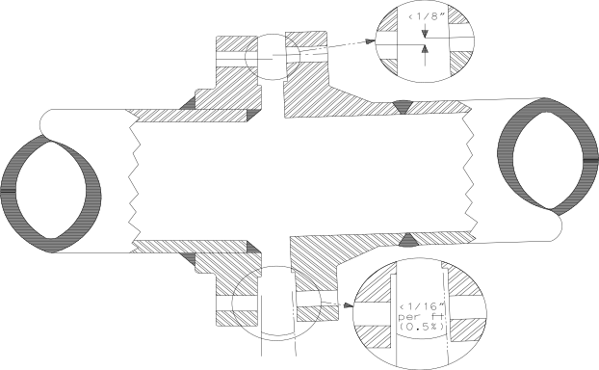
Figure 1 – B31.3 Maximum Flange Misalignment Criteria

Table 3 - B31.3 Maximum Allowable Gap for Class 150, 300, and 600 Flanges
Pipe Size (NPS) | Maximum Allowable Gap (in.)
 | Class 150 | Class 300 | Class 600
½ | 0.018 | 0.020 | 0.020
¾ | 0.020 | 0.024 | 0.024
1 | 0.022 | 0.025 | 0.025
1 ½ | 0.026 | 0.032 | 0.032
2 | 0.031 | 0.034 | 0.034
3 | 0.039 | 0.043 | 0.043
4 | 0.049 | 0.052 | 0.056
6 | 0.057 | 0.065 | 0.073
8 | 0.070 | 0.078 | 0.086
10 | 0.083 | 0.091 | 0.104
12 | 0.099 | 0.107 | 0.115

******************************************************************************************************************
If approved by the engineering design, heat may be used to relieve the pipe stress, bend the pipe, and aid in piping alignment.

335.1 (b) Heating shall not be used to help in closing the gap because it defeats the purpose of cold springing.
******************************************************************************************************************
      - In joints where one or more of the flanges are not attached to piping or vessels, such as cover plates and tube bundles, use minimum-necessary and reasonable force to accomplish the best aligned condition.
      - When no external alignment devices are used, the flanges should be brought into contact with the uncompressed gasket uniformly across the flange faces using all the bolts/studs less than the equivalent of 10% of the total target assembly bolt load. When aligning the flanges, no single bolt should be tightened above 20% of the single bolt maximum torque or target bolt load.
      - When external alignment devices are used, the flanges should be brought to the compressed gasket thickness uniformly across the flange faces using an external load equivalent to less than 20% of the total target assembly bolt load. If more force is required to bring the flange gap into compliance, consult an engineer.
      - Repair the misaligned component by replacing it, correctly removing and reinstalling it in the properly aligned position, [or using uniform heat to relieve the stresses].
    - Gaskets
      - No more than one gasket shall be used between contact faces in assembling a flanged joint.
      - Ensure that gaskets are of the correct material and size. Gaskets must be clean and damage free; not bent, broken, torn, nicked, or distorted in any manner. The allowable shelf life must be checked.
      - No more than one gasket shall be used between contact faces in assembling a flanged joint.
      - Do not cut or deform a gasket to fit a flange. If the gasket doesn’t fit, the wrong one has been chosen.
- FLANGE ASSEMBLY
    - Special Instructions
      - When a flanged joint has been made up and subsequently loosened, the joint shall be cleaned, and a new gasket installed, prior to retightening the joint.
      - Electrical isolation kits shall be used when mating dissimilar metals.
      - Place a new gasket in position after determining the absence of (or having made correction for) unacceptable gasket sealing surface imperfections and flatness tolerance deviations, as well as joint alignment considerations
      - Verify that the gasket complies with the dimensional (O.D., I.D., thickness) and material specifications.
      - Position the gasket to be concentric with the flange I.D., taking suitable measures to ensure that it is adequately supported during the positioning process. No portion of the gasket should project into the flow path.
******************************************************************************************************************
Particular care should be taken to avoid adhesive chemistry that is incompatible with the process fluid or could result in stress corrosion cracking or pitting of the flange surfaces. Allowable and/or prohibited adhesive materials must be identified in the Section.
******************************************************************************************************************
      - Spray very light dusting of spray adhesive on the gasket (not the flange).
      - Ensure that the gasket will remain in place during the joint assembly process.
      - Do not use tape strips radially across the gasket to hold it in position. Do not use grease
      - Do not draw the flange up tight on one or two bolts only. This will cause local gasket crushing or pinching and will ultimately result in a leaking flange
    - Flange Assembly
      - Number the bolts/studs and the nuts clockwise as an aid to identification and for applying the criss-cross bolt tightening sequence clockwise on the flange in accordance with Figure 2.

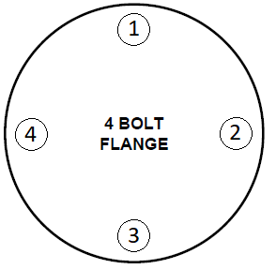
Figure 2, 4-Bolt Flange Numbering
      - Hand-tighten the stud bolts with a short wrench first before torquing.
      - The pattern in which bolts are tightened is extremely important. If performed improperly, tightening can cause the flange to move out of parallel. A staggered crisscross-torqueing pattern, shown in Figure 2, must be used to tighten the bolts.
      - Insert the bolt/stud through the flange and, if necessary, lubricate the threads (see Pre Assembly).
      - Install hardened steel washers and install nuts with raised lettering on the facing outward.
      - Use only calibrated torque wrenches and multipliers. Examine the torque wrench for proper calibration, damage, and proper range. Torque wrenches can be used only within the range specified by the wrench manufacturer. Specified working ranges typically vary from 25% - 75% to 20% - 100% of the full torque wrench range.
      - Appropriate calculations must be made when using multipliers, a crow’s foot, or any other attachment which adds length to the torque wrench (cheater bars are not acceptable). Consult an engineer for adjustment to the appropriate torque setting.
      - Prior to bolting up, flange faces shall be aligned properly. Ideally, the flange faces should be parallel to within 1/16 in/ft. (0.5%) measured across any diameter and the bolt holes shall be aligned within 1/8” maximum offset (ref. Figure 1–B31.3 Maximum Flange Misalignment Criteria).
    - Required Torque
      - Torque tolerances:
        - +/- 2 ft-lbs if torque value is less than 50 ft-lbs
        - +/- 4 ft-lbs if torque value is greater than 50 less than 100 ft-lbs
        - +/- 4% of torque value if greater than 100 ft-lbs.
*****************************************************************************************************************
Note: The tightening sequence for the flange is from ASME PCC-1 Table 4.1. Define the assembly pattern to use in the Section.

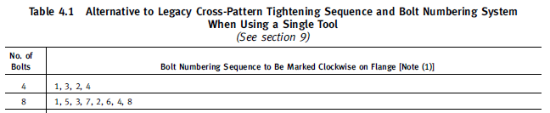
******************************************************************************************************************
      - The tightening sequence for the flange shall be based on Table 4 following.
Table 4 Torque Sequence
Number of Bolts | Bolt Torquing Sequence
4 | 1, 3, 2, 4
      - The following Table 5 shall be the final torque values applied to the flange joints required in this design.
******************************************************************************************************************
Note: Only one size with two different gaskets is shown in the final torque table. However, this table will contain all the flange torques required for the design. ASME PCC-1 Appendix O Assembly Bolt Stress Determination can be used to calculate the bolt torque requirements.

In addition to initial compression, a residual compression value, after internal pressure is applied, is required to maintain the seal. A minimum residual gasket compression of 4 to 6 times the working pressure is standard practice.

Flange Size | Gasket | Uncoated Bolts  Final Torque (ft-lbs) | Coated Bolts  Final Torque (ft-lbs) | Lubricated Bolts  Final Torque (ft-lbs)
4 inch | SWG | 145 | 120 | 120
4 inch | SBR | 80 | 66 | 66
Notes: Spiral-wound (SWG) versus rubber (SBR).

ASME PCC-1
“It is recognized by Appendix S of the ASME Boiler and Pressure Vessel Code, Section VIII, Division 1 that the initial tightening of the bolts in a joint comprising flanges designed in accordance with Appendix 2 of that Code is a prestressing operation and that the level of required Target Bolt Prestress can vary considerably above the code tabulated design-stress value. This is an acceptable and usually required practice. Appendix S states that “. . . an initial bolt stress higher than the design value may and, in some cases, must be developed in the tightening operation, and it is the intent of this Division that such a practice is permissible, provided it includes necessary and appropriate provision to ensure against excessive flange distortion and gross crushing of the gasket.” For joints custom designed in accordance with Appendix 2, a common range of Target Bolt Prestress that is often found acceptable is around 40% to 70% of the specified minimum yield strength of the bolt material. This range is normally only exceeded in exceptional cases that have been assessed by a qualified engineer. However, any maximum Target Bolt Prestress must be selected to ensure that all three of the joint components—bolts, flange, and gasket—are stressed within acceptable limits.”

Alternatively, each joint may be specified using a design data sheet. An example of a design data sheet is available in Appendix C, Example of Alternative Gasket/Bolting Design Data Sheet.
******************************************************************************************************************
Table 5 – Final Torque Values
Flange Size | Gasket | Coated Bolts  Final Torque (ft-lbs)
4 inch | Spiral wound (SWG) | 120
4 inch | Rubber (SBR) | 66

      - Tightening shall be done in a minimum of three increments (1/3 of required torque) to reach final torque. No more than one third of the final torque should be achieved during a single step. Table 6 defines the torque increments for installation.
Table 6 - Torque Increments
Flange Size | Gasket | Torque Steps (ft-lbs)
4 inch | Spiral wound (SWG) | 40, 80,120
4 inch | Rubber (SBR) | 22, 44, 66
      - Following the first torquing pass confirm that the flanges are parallel. If flanges are not parallel at this point, make two complete passes around the flange at 1/3 of the specified final torque to equalize load in the fasteners and examine again for parallelism. If the flanges are not parallel and full-face contact has not been achieved, engineering must evaluate for excessive misalignment.
    - Post-Assembly
      - When sequential torquing is complete, use rotational and reverse rotational tightening to check that all nuts are stable. Verify nuts are stable when the torque wrench does not turn before the wrench achieves the final bolt torque value.
      - Nuts shall have full thread engagement on the bolts or studs. One to two exposed threads is the preferable requirement that defines full thread engagement. The minimum acceptable engagement is the outer edge of the nut being not less than flush with the end of the bolt or stud.
      - Visually check to ensure against excessive flange distortion and gross crushing of the gasket.
      - Check the flange face-to-face separation once the gasket has been installed and the bolts tensioned. A uniform separation is required. If not, the gasket could be locally crushed or deformed and will not seal properly.
      - [Re-torque after 48 hours, and/or after 1 complete thermal cycle].
      - For gas leak testing it is common practice to leak test flange joints by carefully wrapping and sealing the joint with tape, punching a small hole in the tape and applying leak test solution to the hole. Any bubbling thus indicates leakage at the flange joint. Pressure-sensitive masking tape or cloth-backed, pressure-sensitive tapes of either the waterproof or water-vapor-resistant types may be used.
APPENDIX A
ASME B16.5 Fasteners

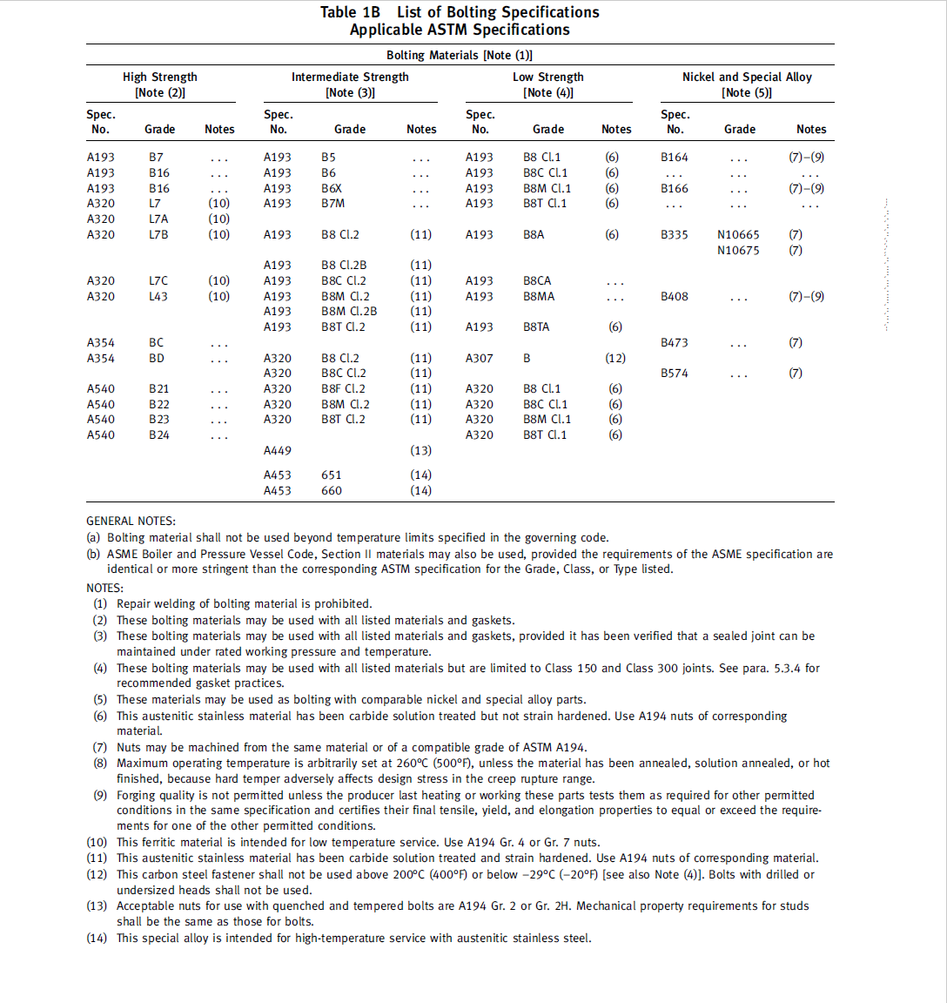
APPENDIX B
B16.5 Class 150 Fasteners
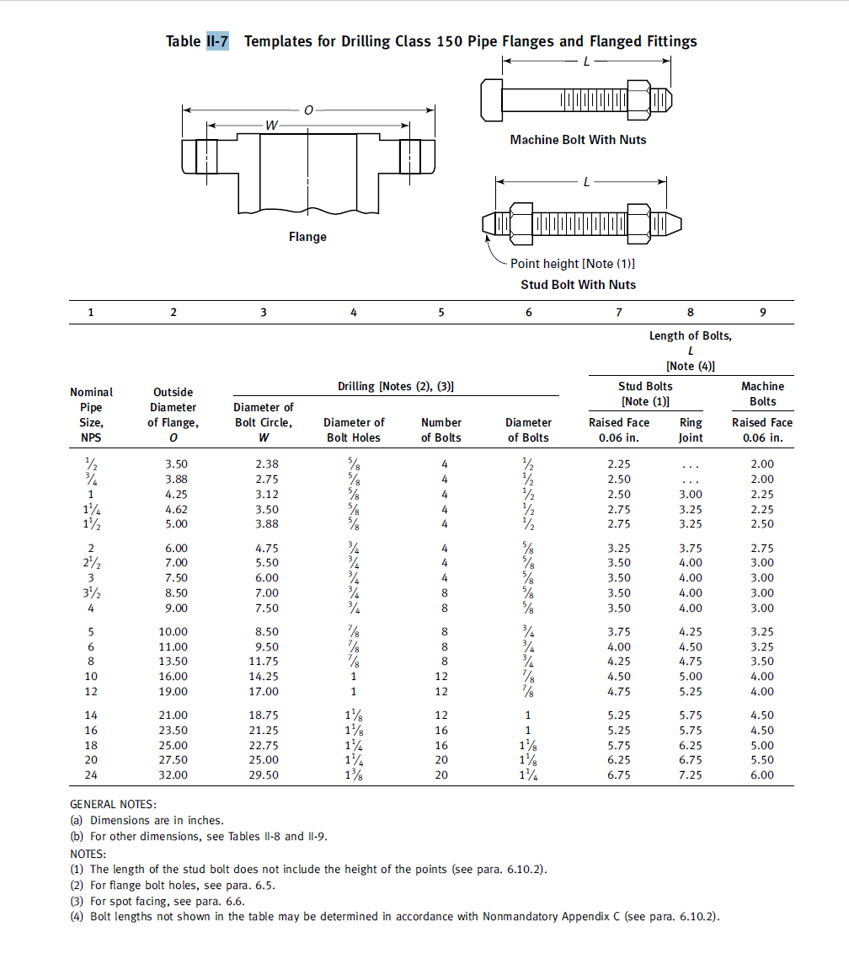
APPENDIX C
Example of Alternative Gasket/Bolting Design Data Sheet
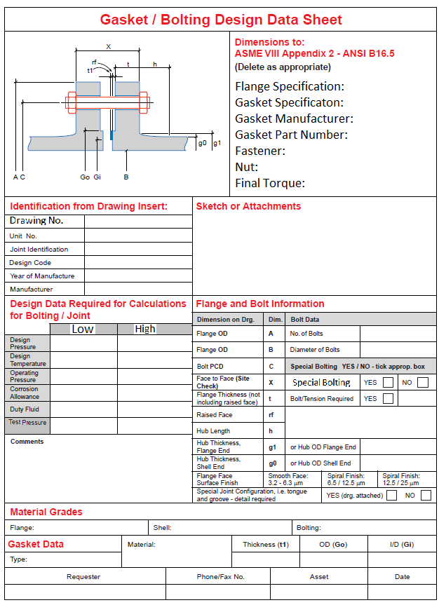

END OF SECTION
***********************************************************
Do not delete the following reference information:
***********************************************************
THE FOLLOWING STATEMENT IS FOR LANL USE ONLY
This project specification section is based on LANL Master Specification Section 01 4731, Rev. 1, dated June 2, 2022.

Before allowing the use of jacks or wrench devices, a pipe stress analysis may be appropriate, especially if the pipe is old or it is suspected that the walls have thinned from use.

