Section 26 0553
Identification for Electrical Systems

************************************************************************************************************

LANL MASTER SPECIFICATION SECTION
Rev. 8 Summary of Changes: Edited and updated as required for import into SpecLink.

NOTE TO SPECIFIER ON USAGE IN SPECLINK: Activate the Section by turning on Seq #0000, followed by activating paragraphs in PART 1, Article SECTION INCLUDES. This will activate related articles, paras/subparas in the rest of the Section (i.e., SECTION INCLUDES in PART 1 activates articles and paras/subparas in PARTS 2 and 3). If there are choice fields to edit the entire Section (typically in this first author note or beginning of the Section), make selections at those locations, which will filter through the remaining Section. All Articles, paragraphs and subparagraphs must be activated sequentially from top to bottom, unless noted otherwise.

This template must be edited for each project. In doing so, Specifier must add job-specific requirements. Selections and choice fields are used to indicate designer choices or locations where text must be supplied by the designer. The section must also be edited to remove requirements for processes, items, or designs that are not included in the project.

To seek a variance from applicable requirements in this Section, contact the Engineering Standards Manual (ESM) Electrical POC (LANL access only). Please contact POC with suggestions for improvement as well. LANL personnel should submit here: Suggested Change or Request Clarification; subcontractors via email to engstandards@lanl.gov.

When assembling a specification package, include applicable Sections from all Divisions, especially Division 1, General Requirements.

Section is developed for ML-4 projects. For ML-1, 2, and 3 applications, additional requirements and independent reviews should be added if increased confidence in procurement or execution is desired; see LANL ESM Chapter 1 - General, Section Z10 Specifications and Quality Requirements.

************************************************************************************************************
  - PART 1 - GENERAL
    - SECTION INCLUDES

***************************************************************************************

The following paragraphs are designer-choice based on project-specific requirements.

***************************************************************************************
      - Component identification tags.
      - Equipment nameplates.
      - Switch and receptacle labels.
      - Wire markers.
      - Voltage markers.
      - Emergency system identification.
      - Arc flash and shock hazard warning labels.
      - Working space floor markings.
      - Working space labels.
      - One-line diagram cabinets.
    - RElated requirements
      - ​Section << 01 2500 - Substitution Procedures>>​
    - reference standards
      - 10 CFR 851 - Worker Safety and Health Program.
      - 29 CFR 1910.145 - Accident Prevention Signs and Tags.
      - ANSI Z535.1 - American National Standard for Safety Colors.
      - ANSI Z535.2 - American National Standard for Environmental and Facility Safety Signs.
      - ANSI Z535.3 - Criteria for Safety Symbols.
      - ANSI Z535.4 - American National Standard for Product Safety Signs and Labels.
      - ANSI Z535.5 - Safety Tags and Barricade Tapes.
      - NFPA 70 - National Electrical Code.
      - NFPA 70E - Standard for Electrical Safety in the Workplace.
      - UL 969 - Marking and Labeling Systems.
    - informational SUBMITTALS
      - Electrical identification schedule including list of wording, symbols, letter size, color-coding, tag information/number, location, and function.
    - REGULATORY REQUIREMENTS
      - Conform to requirements of <<NFPA 70E>>​.
      - Conform to applicable requirements of the following ANSI Standards:
        - <<ANSI Z535.1>>
        - <<ANSI Z535.2>>
        - <<ANSI Z535.3>>
        - <<ANSI Z535.4>>
        - <<ANSI Z535.5>>​​​
    - COORDINATION
      - Coordinate identification names, abbreviations, colors, and other features with requirements in the Subcontract Documents, Shop Drawings, and manufacturer's wiring diagrams with those required by codes, standards, and <<29 CFR 1910.145>>​. Use consistent designations throughout Project.
      - Verify electrical equipment designations with LANL through the Subcontract Technical Representative.
  - PART 2 - PRODUCTS

**********************************************************************************************

The following Articles in Part 2 are designer-choices, based on project-specific requirements.

**********************************************************************************************
    - PRODUCT OPTIONS AND SUBSTITUTIONS
      - Alternate products may be accepted; follow Section << 01 2500 - Substitution Procedures>>​.

***************************************************************************************

Provide a schedule for component identification tags on the Drawings. Refer to LANL ESM Chapter 7 - Electrical Section D5000 (Part 7.0) and LANL ESM Chapter 1 - General, Section 200 on Item Numbering and Labeling.

***************************************************************************************
    - COMPONENT IDENTIFICATION TAGS
      - Furnish component identification tags as specified below ​<< and scheduled on the Drawings; or None - N/A>>​ to identify electrical equipment using the system ID, equipment identification, tech area number, and building number.
      - Coordinate electrical component identification tag schedule with LANL system engineer (local variation may exist) and final equipment identification scheme for project.
      - Provide component identification tags with black letters on yellow background with 3 inches by 2 inches dimensions.
      - Provide minimum 48-point size lettering (2/3 inch).
      - Provide tags made of one of the following materials:
        - Type 1 (Indoor Applications Only):
          - Laminated plastic adhesive tape with machine printed letters.
          - Manufacturer: Brother, Seton, Brady.
        - Type 2:
          - Two-ply plastic nameplate with letters engraved through yellow surface showing black core.
          - Provide UV stabilized material for outdoor applications.
          - Manufacturer: Seton Nameplate Corp.

***************************************************************************************

Provide a schedule for equipment nameplates on the Drawings.

Refer to LANL ESM Chapter 7 - Electrical, Section D5000 Part 7.0. Three phase systems have the larger voltage first, e.g., 480/277. Single phase systems have the smaller voltage first, e.g., 120/240.

***************************************************************************************
    - EQUIPMENT NAMEPLATES
      - Furnish equipment nameplates as specified below ​<< and scheduled on the Drawings; or None - N/A>>​ to indicate the following information:
        - Category I nameplates:
          - Supplied by nameplates: circuit directory information including circuit number, equipment identification, location of equipment supplying the item, and the circuit voltage (e.g., 480Y/277V, 480V 3Ø, 208Y/120V, 120/240V).
          - Supplies nameplates: circuit directory information including circuit number, equipment identification, location of equipment being supplied, and the circuit voltage (e.g., 480Y/277V, 480V 3Ø, 208Y/120V, 120/240V).
        - Category II nameplates – general or operational information including basic instructions or specific operating procedures.
        - Category III nameplates – emergency operations information including emergency shutdown procedures.
      - Coordinate equipment nameplate schedule with equipment numbering scheme provided on the drawings, or by the Subcontract Technical Representative.
      - Provide nameplates made of one of the following materials:
        - Type 1 (Indoor Applications Only):
          - Laminated plastic adhesive tape with machine printed letters.
          - Manufacturer: Brother, Seton, Brady.
        - Type 2:
          - Two-ply plates with letters engraved through surface color showing core color.
          - Use UV stabilized material for outdoor applications.
          - Manufacturer: Seton Nameplate Corp.
      - Provide 10-point-minimum size lettering.
      - Provide colors as follows:
        - Category I nameplates: white letters on blue background.
        - Category II nameplates: white letters on black background.
        - Category III nameplates: white or black letters on red background.
      - Dimensions shall be as follows:
        - Category I nameplates: 2-1/2 inches by 1 inch minimum.
        - Category II nameplates: as required for instructions, 2-1/2 inches by 1 inch minimum.
        - Category III nameplates: as required for instructions, 2-1/2 inches by 1 inch minimum.

***************************************************************************************

Refer to LANL ESM Chapter 7 - Electrical, Section D5000 Part 7.0.

***************************************************************************************
    - SWITCH AND RECEPTACLE LABELS
      - Furnish a typewritten or machine printed label for each switch and receptacle indicating circuit number, panelboard, and voltage.
      - Provide labels of the following materials:
        - Laminated plastic adhesive tape with machine printed letters.
        - Manufacturer: Brother, Seton, Brady.
      - Provide black, 10-point-minimum size lettering on a white background.
    - WIRE MARKERS
      - Provide wire markers for power, control, instrumentation, alarm, and communication circuit wires that indicate the panel and circuit designation
      - Furnish split sleeve, heat-shrinkable sleeve, or self-laminating adhesive wire markers.
      - Locate a wire marker on each conductor at each termination and splice point.
      - Manufacturer: Brady, Panduit, LEM Products, Inc.
    - VOLTAGE MARKERS
      - Furnish voltage markers, as required, to identify voltages present in equipment
        - For medium voltage, in addition to the above, furnish voltage markers for pull boxes and raceways.
      - Provide flexible pressure sensitive vinyl markers with minimum 4 inches by 1 inch orange background and black letters.
      - Provide voltage markers with lettering indicating all voltages present:

Note: For three-phase systems, the higher voltage is listed first. For single-phase systems, the lower voltage is listed first.
        - 120 or 208Y/120.
        - 120, 240, or 120/240.
        - 480.
        - 480Y/277.
        - 15 kV.
        - Fire alarm system: FIRE ALARM
        - Telephone/data system: TELEPHONE
      - Manufacturer: Electromark, LEM Products, Inc.

***************************************************************************************

This article is for Emergency systems as defined in Article 700 of NFPA 70. For example, NFPA 70 requires the marking of emergency circuits so they will be readily identified as components of an emergency system.

***************************************************************************************
    - EMERGENCY SYSTEM IDENTIFICATION
      - Furnish identification for emergency system components as required below and <<NFPA 70>> Article 700.

***************************************************************************************

NOTE: The following paragraph only applies to emergency systems. It does not apply to legally required standby or optional standby systems..

***************************************************************************************
      - Provide flexible pressure sensitive vinyl markers with minimum 4 inches by 1 inch orange background and black letters indicating EMERGENCY SYSTEM.

***************************************************************************************

Refer to LANL ESM Chapter 7 - Electrical, Section D5000 (Part 7.0).

***************************************************************************************
    - ARC FLASH AND SHOCK HAZARD WARNING LABELSand shock Hazard WARNING LABELS
      - Furnish arc flash and shock hazard warning labels, as indicated in approved construction documents.
      - Provide warning labels that comply with <<ANSI Z535.4>>. The color in top part of WARNING labels shall be ANSI “safety orange” and the signal word lettering black. The color in top part of DANGER labels shall be red and the signal word lettering white.
      - Provide either machine-produced custom labels or manually filled-in pre-printed labels that meet the requirements below.
        - Label dimensions shall be approximately 4 inches high by 6 inches wide.
        - Outdoor labels shall be suitable for a high-UV environment.
        - Machine-produced custom labels:
          - Use polyester label stock that is NRTL-recognized to <<UL 969>>, and has a high-adhesion adhesive back.
          - Use printing ribbon recommended by the label stock manufacturer.
          - Use a suitable thermal transfer process label-printing machine to generate labels.
        - Pre-printed labels:
          - Use labels printed on self-adhesive UV-resistant polyester with pressure-sensitive adhesive back. Provide labels with a clear polyester overlay film to protect manually entered information.
          - Use a black, UV-resistant, industrial permanent marker pen to legibly hand letter the required information.

***************************************************************************************

The following paragraphs are designer-choices, depending on the hazards present on the project.

Labels are defined by ANSI Z535.4. The "Signal Word" appears at the top. This will either be "Danger," "Warning," "Caution," or "Notice." The "Message" appears below the "Signal Word."

***************************************************************************************
      - Use Shock Hazard Warning Label Design #1 for equipment that has an incident energy less than 1.2 cal/sq. cm. at a working distance of 18 inches.
        - Operating at a nominal system voltage less than 240 V and fed by a transformer with a rating less than 125 kVA, supplied by a three-phase system.
        - Operating at 120 volts, regardless of the size of the transformer feeding the system.

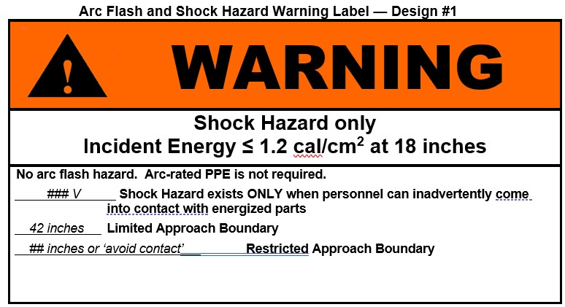
        - Manufacturer: Summit Electric Supply, Seton Name Plate Co., Safety Label Solutions, Hazard Communication Systems, Electromark, Brady.
      - Use Arc Flash and Shock Hazard Warning Label Design #2 for equipment where the criteria for use of Design #1 are exceeded but the calculated arc flash incident energy does not exceed 40 cal/sq. cm. For the working distance, use 18 inches for non-drawout gear and 24 inches for drawout gear. For the Restricted approach boundary, use ‘Avoid Contact’ when the voltage present is 120 Volts. Use ’12 Inches’ for everything else. (208/120, 480/277, 480)

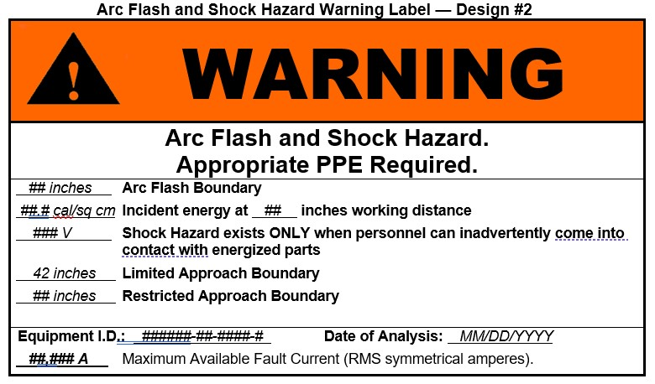
        - Manufacturer: Summit Electric Supply, Seton Name Plate Co., Safety Label Solutions, Hazard Communication Systems, Electromark, Brady.
      - Use Arc Flash and Shock Hazard Warning Label Design #3 for equipment where the calculated arc-flash incident energy is greater than 40 cal/sq. cm. at the given working distance; use 18 inches for non-drawout gear, 24 inches for drawout gear. In addition to this, calculate the distance where the incident energy is equal to, or just less than, 40 cal/sq. cm. and include this calculated distance in the third line. This is to allow the worker to make field decisions as to if a piece of equipment can be operated.

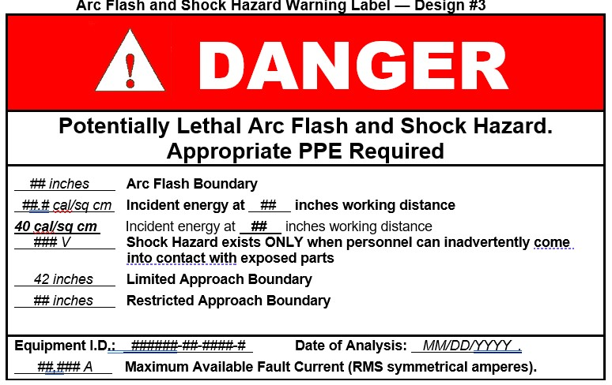
        - Manufacturer: Summit Electric Supply, Seton Name Plate Co., Safety Label Solutions, Hazard Communication Systems, Electromark, Brady.

***************************************************************************************

Refer to LANL ESM Chapter 7 - Electrical, Section D5000 (Part 7.0). Painting the floor is usually only done in warehouse type areas in order to prevent materials being placed in the working space.

***************************************************************************************
    - WORKING SPACE FLOOR MARKINGS
      - Provide black paint and white paint to mark the NEC-required working space on the floor at electrical equipment, if shown on drawings.
    - WORKING SPACE LABELS
      - Provide labels indicating required working clearance at switchgear, switchboards, panelboards, and other equipment as shown on drawings.
      - Material:
        - Use polyester label stock that is NRTL-recognized to <<UL 969>>​​,, and has a high-adhesion adhesive back.
        - Use printing ribbon recommended by the label stock manufacturer.
        - Use a suitable thermal transfer process label-printing machine to generate labels and enter the application-specific information
        - Outdoor labels shall be suitable for a high-UV environment.
      - Minimum dimensions: 3-1/2 x 1-1/4 inches.
      - Use the following label design:

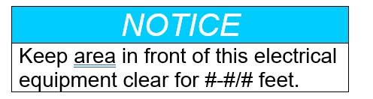
        - Signal word: “NOTICE” in 24-point-minimum white italic letters on safety blue panel.
        - Word message: 16-point-minimum black or safety blue letters on white background. The number of feet is given by the following table.

******************************************************************************

Edit Table 1 to reflect project-specific requirements. Remove rows in table that do not apply. Verify distances, and conditions, with NFPA 70, 110.26(A)

******************************************************************************

Table 1-WSL
Equipment Hazard | Number of Feet for Word Message
120/240V and 208Y/120V | 3
480V and 480Y/277V with exposed live parts on one side of the working space and no live parts on the other side of the working space | 3-1/2
480V and 480Y/277V with exposed live parts on both sides of the working space | 4
4160Y/2400V with exposed live parts on one side of the working space and no live parts on the other side of the working space | 4
4160Y/2400V with exposed live parts on both sides of the working space | 5
13,200V with exposed live parts on one side of the working space and no live parts on the other side of the working space | 5
13,200V with exposed live parts on both sides of the working space | 6
      - Manufacturer: Brother, Seton, Brady.

***************************************************************************************

Include the following article for indoor major pieces of equipment, such as switchgear and switchboards.

***************************************************************************************
    - ONE-LINE DIAGRAM CABINET(S)
      - Provide aluminum framed bulletin board cabinet(s) to display electrical one-line diagram(s) plus special operating instructions and emergency procedures as shown on Drawings.
        - Housing: Extruded aluminum with manufacturer’s standard outside dimensions of approximately << 48 inches x 36 inches; 60 inches x 36 inches; 60 inches x 48 inches; or 72 inches x 48 inches>> x 3 inches deep.
        - Doors: Two sliding 3/16 inch tempered glass doors with ground-in finger pulls and flat key tumbler locks.
        - Back panel: Tackable cork.
        - Finishes: Manufacturer’s standard finishes and colors.
      - Manufacturer: Claridge “Imperial Series”.
  - PART 3 - EXECUTION
    - EXAMINATION
      - Examine surfaces to receive identification products for compliance with installation tolerances and other conditions affecting performance of the identification products. Do not proceed with installation until unsatisfactory conditions have been corrected.
    - INSTALLATION - GENERAL
      - Where identification is to be applied to surfaces that require finish, install identification after completion of finish work.
      - Install labels where indicated and at locations for best convenience of viewing without interference with operation and maintenance of equipment.
        - Coordinate installation of identifying devices with location of access panels and doors.
        - Where the required labels do not fit on the face of the equipment, labels may be placed on a plate immediately adjacent to or above the equipment.
      - Install electrical identification products only when ambient temperature and humidity conditions for adhesive are within range recommended by manufacturer.
      - Clean surface where electrical identification product is to be placed.
      - Use manufacturer's recommended adhesive for engraved tags and nameplates.

***************************************************************************************

Refer to LANL ESM Chapter 7 - Electrical, Section D5000 (Part 7.0). For equipment nameplates, refer to LANL Electrical Standard Detail D5000-3 for locations.

***************************************************************************************
    - COMPONENT IDENTIFICATION TAG installation
      - Install component identification tag on the front of each piece of electrical equipment as indicated on the Drawings.
      - Position tags so they can be read from floor or ground.
    - EQUIPMENT NAMEPLATE installation
      - Install equipment nameplate or nameplates on the front of each piece of electrical equipment as indicated on the Drawings.
      - Important Equipment: Install a Category III nameplate at the branch circuit breaker(s) that provide(s) AC power to the following equipment per Table 2-IEN.

Table 2-IEN
Component | Nameplate Wording
Important Equipment Type | Branch Circuit Breaker(s) Nameplate Wording
Fire alarm control panel | WARNING – AC POWER TO FIRE ALARM CONTROL PANEL – DO NOT TURN OFF WITHOUT AUTHORIZATION
Other life safety system components | WARNING – AC POWER TO LIFE SAFETY SYSTEM – DO NOT TURN OFF WITHOUT AUTHORIZATION
Other safety systems | WARNING – AC POWER TO SAFETY SYSTEM – DO NOT TURN OFF WITHOUT AUTHORIZATION
Security system components | WARNING – AC POWER TO SECURITY SYSTEM – DO NOT TURN OFF WITHOUT AUTHORIZATION
      - Position nameplates so they can be read from floor or ground.
    - SWITCH OR RECEPTACLE LABEL installation
      - Install label on outside of device cover for each receptacle and light switch.
    - WIRE MARKER installation
      - Install wire markers on power, control and communication conductors at each termination or splice point
    - VOLTAGE MARKER installation
      - Install voltage markers at the following locations and position markers so they can be read from floor or ground:

******************************************************************************

The following subparagraphs concerning "medium-voltage" are designer-choices, based on the presence of medium-voltage equipment on the project.

******************************************************************************
        - Front and rear of each medium-voltage switchgear assembly.
        - Front and rear of each free-standing low- voltage switchgear or switchboard section.
        - Front of each transformer, switchgear, switchboard, panelboard, industrial control panel, starter, VFD, motor control center, enclosed circuit breaker, safety switch, and cabinets, including those furnished with mechanical equipment.
        - Cover of each pull box containing medium-voltage conductors.
        - Raceways containing medium-voltage conductors. Space markers not more than 20 feet on center.
        - Voltage markers must only include the voltages present. E.g., for a 480-volt system with no neutral, the voltage marker must be “480” instead of “480/277.”

***************************************************************************************

Note: A system is only “Emergency” if it is defined as such by the Authority Having Jurisdiction. In this case, it must meet the requirements of NFPA 70 Article 700. Other systems are either “Legally Required Standby” per NFPA 70 Article 701, or “Optional Standby” per NFPA 70 Article 702. LANL has very few, if any, emergency systems.

***************************************************************************************
    - EMERGENCY SYSTEM IDENTIFICATION installation
      - Install identification for emergency system markers at the following locations and position markers so they can be read from floor or ground:
        - Front of each emergency system generator.
        - Front and rear of each free-standing emergency system switchgear or switchboard section.
        - Front of each low-voltage transformer, panelboard, industrial control panel, motor control center, enclosed circuit breaker, safety switch, and motor controller enclosure, including those furnished with mechanical equipment.
        - Cover of each pull box and junction box containing emergency system conductors.
        - Each emergency system conduit longer than 6 feet; space markers not more than 20 feet on center.
        - The front or cover plate of each receptacle supplied from the emergency system.
    - ARC FLASH AND SHOCK HAZARD WARNING LABEL installation
      - Install arc-flash and shock-hazard warning labels at all locations shown on the Drawings.
    - WORKING SPACE FLOOR MARKing installation
      - Install floor marking paint on the floor at the locations as shown on Drawings.
      - Dimensions of working space area shall be as follows:
        - Width: the greater of the width of the equipment or 30 inches.
        - Depth: The same number of feet as required by the Working Space label wording in Table 1-WSL in PART 2 above.
      - Thoroughly prepare floor surface to receive paint.
      - Paint the NEC-required working space area with alternating 3 to 6 inch wide black and white diagonal stripes.

***************************************************************************************

Use working space labels only where it is impractical to mark the NFPA 70 required working space on the floor (e.g., carpeted areas). Refer to LANL ESM Chapter 7 - Electrical, Section D5000 (Part 7.0).

***************************************************************************************
    - WORKING SPACE LABEL installation
      - Install working space labels on switchgear, switchboards, panelboards, and where shown on Drawings
      - Position labels so they can be read from floor or ground.
    - ONE-LINE DIAGRAM CABINET installation
      - Install one-line diagram cabinet(s) in the locations shown on Drawings.

END OF SECTION

**********************************************************************************************

Do not omit the following reference information:

**********************************************************************************************
  - THE FOLLOWING STATEMENT IS FOR LANL USE ONLY
  - THIS PROJECT SPECIFICATION SECTION IS BASED ON LANL MASTER SPECIFICATION SECTION 26 0553, REV. 8, DATED APRIL 15, 2026.

