Section 26 0813
Electrical Acceptance Testing

*************************************************************************************************************

LANL MASTER SPECIFICATION SECTION
Rev. 5 Summary of Changes: Edited and updated as required for import into SpecLink.

NOTE TO SPECIFIER ON USAGE IN SPECLINK: Activate the Section by turning on Seq #0000, followed by activating paragraphs in PART 1, Article SECTION INCLUDES. This will activate related articles, paras/subparas in the rest of the Section (i.e., SECTION INCLUDES in PART 1 activates articles and paras/subparas in PARTS 2 and 3). If there are choice fields to edit the entire Section (typically in this first author note or beginning of the Section), make selections at those locations, which will filter through the remaining Section. All Articles, paragraphs and subparagraphs must be activated sequentially from top to bottom, unless noted otherwise.

This template must be edited for each project. In doing so, Specifier must add job-specific requirements. Selections and choice fields are used to indicate designer choices or locations where text must be supplied by the designer. The section must also be edited to remove requirements for processes, items, or designs that are not included in the project.

To seek a variance from applicable requirements in this Section, contact the Engineering Standards Manual (ESM) Electrical POC (LANL access only). Please contact POC with suggestions for improvement as well. LANL personnel should submit here: Suggested Change or Request Clarification; subcontractors via email to engstandards@lanl.gov.

When assembling a specification package, include applicable sections from all Divisions, especially Division 1, General Requirements.

Section is developed for ML-4 projects. For ML-1, 2, and 3 applications, additional requirements and independent reviews should be added if increased confidence in procurement or execution is desired; see LANL ESM Chapter 1 - General, Section Z10 Specifications and Quality Sections.

==========================================================

Use the graded approach outlined in the following table (based on LANL ESM Chapter 7 - Electrical, D5000 on Acceptance Testing) to determine if formal electrical acceptance testing as described in this Section is required for specific electrical systems or components.

1. If the indicated threshold is not exceeded for a system or component type, then formal electrical acceptance testing as described in this Section is not required for the specific electrical system or component. Still required would be the Subcontractor- or equipment manufacturer-performed field inspections and tests described in the Section specific to that system or equipment.

2. If the indicated threshold is exceeded for a system or component type, then that system must receive formal electrical acceptance testing and inspections in accordance with this Section using the current edition of NETA ATS–Acceptance Testing Specification.

3. LANL ESM Chapter 15 - Commissioning and LANL ESM Chapter 16 - Building Code Program, or other Specification Sections, may require additional test and inspections that are beyond the scope of this Section; coordinate the tests required in this Section with any Test and Inspection Plan (TIP) that may be developed for the Project.

4. Select the appropriate entity to serve as the Electrical Testing Agency (ETA). On larger or complex projects, the services of a LANL-procured (independent of constructor), qualified electrical testing firm may be necessary.

A. The LANL MSS-CE Low Voltage Electrical Equipment Maintenance (LVEEM) testing crew has the capability to perform testing of equipment (all MLs) that is covered in O&M Criterion 504, Low Voltage Electrical Equipment. MSS Documents: O&M Criterion (LANL access only).

5. If formal electrical acceptance inspection and testing is required for one or more systems or component types, then it may be cost-effective to use the ETA to perform acceptance inspection and testing on the other electrical systems and components addressed by the NETA ATS.

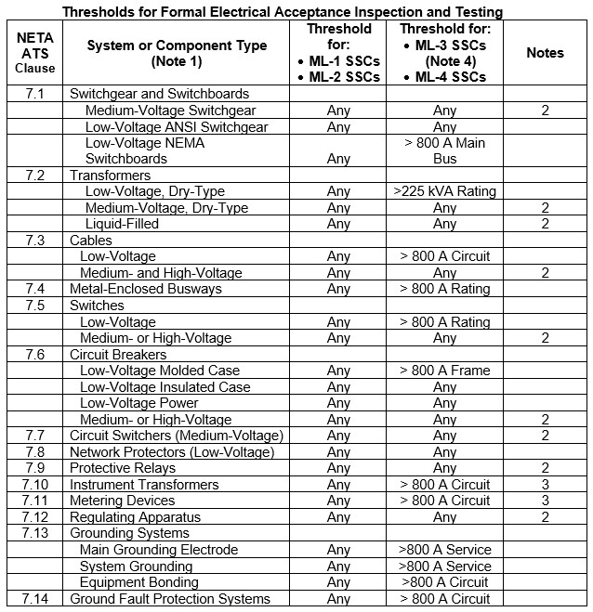

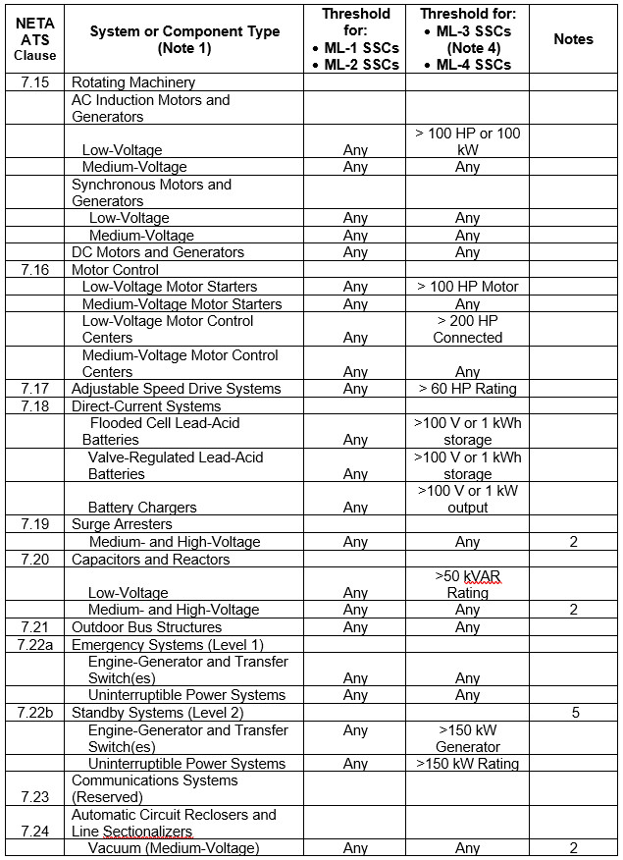

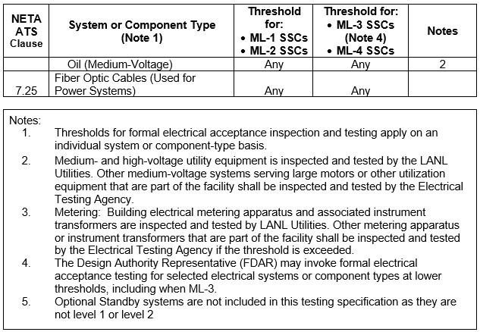

*************************************************************************************************************
  - PART 1 - GENERAL
    - Section Includes
      - Key Subcontractor notifications to LANL of equipment availability for LANL-performed acceptance tests, inspections, and system function tests.
      - LANL-provided services of a qualified Electrical Testing Agency (ETA) to perform the functions described below:
        - Acceptance tests, inspections, and system function tests of certain electrical equipment and conductors installed under the scope of this Project; refer to PART 3 of this Section.
        - System function tests after completion of acceptance tests on certain electrical equipment and conductors installed under the scope of this Project.

******************************************************************************

Edit the following subparagraphs to suit project requirements; retain if applicable to the Project. Coordinate with the LANL Electrical POC. In most cases, the entirety of the third subparagraph should not be retained, as it is the responsibility of the Design Agency, not the testing agency.

******************************************************************************
        - The following power system studies based on the installed electrical Conductors and Equipment:

**********************************************************************

The Project design agent performs a preliminary fault current study during definitive design.

**********************************************************************
          - Final fault current study

**********************************************************************

Coordination studies are only required for ML-1, ML-2, and systems above 800 amps. Retain accordingly. Project design agent performs a preliminary coordination study during definitive design. Once the electrical system has been installed, any new information, e.g. breaker types and settings and/or conductor lengths, will be fed back into the study for final results.

**********************************************************************
          - Final coordination study

**********************************************************************

Coordinate with Section << 26 0553 - Identification for Electrical Systems>>, for required equipment labelling.

**********************************************************************
          - Arc-flash hazard analysis

**********************************************************************

Load flow analysis is required for complex electrical distribution systems with multiple sources and/or parallel circuit paths. Retain accordingly.

**********************************************************************
          - Load flow analysis study

**********************************************************************

Stability analysis is required for electrical distribution systems with onsite co-generation and/or large synchronous motors. Retain accordingly.

**********************************************************************
          - Stability study

**********************************************************************

Harmonic analysis is required for electrical distribution systems with harmonic generating non-linear loads (UPS, adjustable frequency drive, power converter, etc.) constituting more than 25-30% of the connected load. Retain accordingly.

**********************************************************************
          - Harmonic analysis study
    - related requirements
      - Section ​<< 01 3300 - Submittal Procedures>>​.
      - Section ​<< 26 0519 - Low Voltage Electrical Power Conductors and Cables>>​
      - Section ​<< 26 0526 - Grounding and Bonding for Electrical Systems>>​
      - Section ​<< 26 0553 - Identification for Electrical Systems>>​
      - Section ​<< 26 2213 - Low Voltage Distribution Transformers>>​
      - Section ​<< 26 2300 - Low-Voltage Switchgear>>​
      - Section ​<< 26 2413 - Switchboards>>​
      - Section ​<< 26 2416 - Panelboards>>​
      - Section ​<< 26 2419 - Motor-Control Centers>>​
      - Section ​​<< 26 2500 - Enclosed Bus Assemblies>>​​
      - Section ​​​<< 26 2713 - Electricity Metering>>​​​
      - Section ​​<< 26 2816 - Enclosed Switches and Circuit Breakers>>​​
      - Section ​<< 26 2913 - Enclosed Controllers>>​
      - Section ​<< 26 2923 - Variable Frequency Motor Controllers>>​
      - Section ​<< 26 3353 - Static Uninterruptible Power Supply>>​
    - REFERENCE STANDARDS
      - ANSI/NETA ETT - Standard for Certification of Electrical Testing Technicians.
      - IEEE 242 - IEEE Recommended Practice for Protection and Coordination of Industrial and Commercial Power Systems.
      - IEEE 399 - IEEE Recommended Practice for Industrial and Commercial Power Systems Analysis.
      - IEEE 1584 - IEEE Guide for Performing Arc-Flash Hazard Calculations.
      - NETA ATS - Standard for Acceptance Testing Specifications for Electrical Power Equipment And Systems.
      - NFPA 70 - National Electrical Code.
      - NFPA 70E - Standard for Electrical Safety in the Workplace.
      - NFPA 110 - Standard for Emergency and Standby Power Systems.
      - NFPA 111 - Standard on Stored Electrical Energy Emergency and Standby Power Systems.
    - Coordination
      - Schedule the project to allow adequate time for electrical acceptance testing BEFORE equipment or system is energized.
        - Notify the ETA when equipment becomes available for acceptance inspections and tests.
        - Coordinate work to expedite inspections and tests.
      - Notify the LANL Subcontract Technical Representative (STR) at least 14 days in advance to schedule acceptance tests, inspections, and system function tests.
        - Notify the LANL STR again approximately 24 hours before start of testing.
        - The LANL STR will arrange for witnessing of the tests and inspections by appropriate LANL personnel when required by the Test & Inspection Plan, or when deemed appropriate by the LANL Design Authority.
    - ACTION SUBMITTALS
      - Submit the following in accordance with Section ​<< 01 3300 - Submittal Procedures>>​:
        - Certifications: Name and qualifications of the ETA.
        - Certifications: Quality assurance program of the ETA.
        - Certifications: Instrument calibration program of the ETA.
        - Certifications: Electrical safety program of the ETA.
        - Certifications: Submit name and qualifications of the lead engineer or engineering technician performing the required testing services.
        - Test Plans: Acceptance and system functions test plan for each item of equipment or system to be field tested at least 45 days prior to planned testing date. Include applicable procedures, forms, and lists of test equipment. Do not perform testing until test plan and procedures have been approved.
        - Test Reports: Certified copies of inspection reports, test reports, and system function tests. Reports shall include certification of compliance with specified requirements including test instrument calibration, identification of deficiencies, and recommendation of corrective action when appropriate. Type and neatly bind test reports to form a part of the final record. Submit test report not more than 10 days after each test is completed.

******************************************************************************

Edit the following subparagraphs to suit project requirements; If the power study is performed by the design agency the following subparagraph should be omitted. If the power study is performed by an ETA, retain the following subparagraph and its subparagraphs that are applicable to the Project. Refer to the power system descriptions in Article SECTION INCLUDES.

******************************************************************************
        - Calculations: Submit certified copies of power system studies listed below. Calculations shall include certification of compliance with specified requirements, identify deficiencies, and recommend corrective action when appropriate.
          - Final short circuit study
          - Final coordination study
          - Arc-flash hazard analysis
          - Load flow study
          - Stability study
          - Harmonic analysis.
    - LANL REQUIREMENTS
      - Perform inspections and tests in accordance with the following codes and standards:
        - International Electrical Testing Association - <<NETA ATS>>. <<NETA ATS>> forms a part of this Specification to the extent referenced.
    - QUALITY control / quality ASSURANCE
      - The ETA shall be independent of the subcontractors installing the equipment (e.g., a first-tier subcontractor engaged by LANL, or LANL's Low Voltage Electrical Equipment + Maintenance (LVEEM) testing crew in MSS-CE).

***************************************************************************************

On large or complex projects, the services of an external, qualified electrical testing firm subcontracted by LANL may be necessary.

LANL’s LVEEM testing crew in MSS-CE can perform testing of equipment covered in O&M Criterion 504, Low Voltage Electrical Equipment (all MLs) (LANL access only).

***************************************************************************************
      - The ETA shall be regularly engaged in the testing of electrical equipment devices, installations, and systems.
      - The ETA shall have a documented quality assurance program, documented inspection and test and procedures, and a documented electrical safety program.
      - The ETA shall have successfully completed not less than five acceptance testing, inspection, and calibration projects of similar scope to this project.
      - The ETA shall have a calibration program, and test instruments used, for measurements that require calibration, shall be calibrated in accordance with <<NETA ATS>>.
      - ETA technicians performing testing, inspection, calibration, and adjustments shall be:
        - Trained and experienced concerning the apparatus and systems being evaluated.
        - Capable of conducting the tests with awareness of the hazards involved and the appropriate safety-related work practices.
        - Qualified to evaluate the test data and make a judgment on the serviceability of the specific equipment.
      - Testing, inspection, calibration, and adjustments shall be performed or supervised on the Project site by an ETA employee with one of the following minimum qualifications:

******************************************************************************

Choose one or more of the following.

******************************************************************************
        - An engineering technician certified to at least Level III in accordance with <<ANSI/NETA ETT>>​
        - An engineering technician certified to at least the NICET ET-grade in Electrical Testing Engineering Technology.
        - For (a) ML-3 and ML-4 equipment and conductors and/or (b) LANL personnel-performed testing: An engineering technician certified by the ETA’s internal training/qualification program. As part of the submittal of qualifications, ETA must provide material demonstrating that its certification program is at least equivalent to ANSI/NETA ETT Level III and that the onsite technician’s training and certification is up to date.
  - PART 2 - PRODUCTS (not used)
  - PART 3 - EXECUTION
    - GENERAL
      - Perform the installation insulation-resistance, continuity, and rotation tests for electrical equipment and conductors described in each Section of these Specifications before, and in addition to, tests performed by the ETA that are specified in this Section.
      - Supply one set of the following to ETA prior to the performance of any final testing:
        - Fault current analysis.
        - Coordination study and protective device setting table.
        - Complete set of electrical Drawings, Specifications, and any pertinent Change Orders.
        - Approved construction submittal documents for material and equipment.
        - Site specific hazard notification and safety training.
        - Other information necessary for an accurate test and inspection of the system.
    - INspection and Test Procedures
      - The ETA shall use test methods, follow procedures, and evaluate test values in accordance with the applicable sections of the <<NETA ATS>>, the manufacturer's recommendations, and each applicable specification section.
      - Tests identified as optional in <<NETA ATS>> are not required unless specified.
      - The ETA shall perform acceptance tests and inspections on electrical equipment and conductors as identified in the following subparagraphs. Perform tests and inspections as specified in the applicable clauses of the <<NETA ATS>> and as modified by the following subparagraphs:

******************************************************************************

Edit the following subparagraphs to match Project requirements, the construction specifications, and the Management Levels for the equipment and conductors that are part of the project. Retain the subparagraphs pertaining to equipment and conductors that are included in the Project. If necessary, add references to new specification sections for equipment and conductors on the Project for which NETA-ATS has a test/inspection procedure. Note any of the NETA-ATS optional inspections/tests that Project conditions may make necessary. Identify any ML-3 systems or component types for which the Design Authority Representative has invoked more rigorous electrical acceptance testing requirements. LANL ESM Chapter 15 - Commissioning and LANL ESM Chapter 16 - Building Code Program or other Specification Sections may require additional test and inspections that are beyond the scope of this Section; coordinate the tests required in this Section with any Test and Inspection Plan that may be developed for the Project.

******************************************************************************
        - Section ​<< 26 0519 - Low Voltage Electrical Power Conductors and Cables>>​.
          - Test low-voltage conductors using the graded approach indicated in Table 1 below.

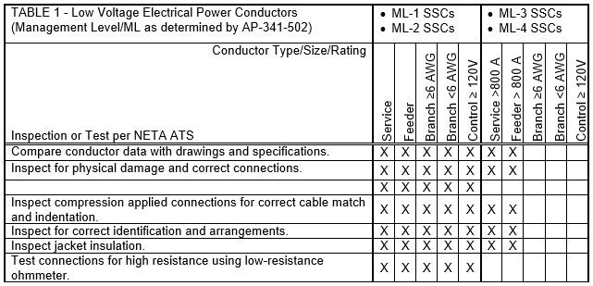
        - Section ​​​<< 26 0526 - Grounding and Bonding for Electrical Systems>>​​​.
          - << ML-1; ML-2; or ML-3>> low-voltage systems: Visually inspect bonding for each system and circuit.
          - << ML-3; or ML-4>> low-voltage systems: Visually inspect grounding and bonding for each system and circuit rated more than 800 amperes.
        - Section ​<< 26 2213 - Low Voltage Distribution Transformers>>​.
          - << ML-1; ML-2; or ML-3>> transformers: Test each transformer.
          - << ML-3; or ML-4>> transformers: Test each transformer rated more than 500 kVA.
        - Section ​<< 26 2300 - Low-Voltage Switchgear>>​.
          - Test each low-voltage switchgear assembly.
          - Test each circuit breaker in each low-voltage switchgear assembly.
        - Section ​<< 26 2413 - Switchboards>>​.
          - << ML-1; ML-2; or ML-3>> switchboards: Test each switchboard and each included circuit breaker.
          - << ML-3; or ML-4>> switchboards: Test each switchboard rated more than 800 amperes. Test each included insulated case circuit breaker and power circuit breaker. Test included molded-case circuit breakers using the graded approach indicated in Table 2 of this Section.
        - Section ​<< 26 2416 - Panelboards>>​.
          - << ML-1; ML-2; or ML-3>> panelboards: Test each panelboard and each included circuit breaker.
          - << ML-3; or ML-4>> panelboards: Test each panelboard rated more than 800 amperes. Test included molded-case circuit breakers using the graded approach indicated in Table 2 below.

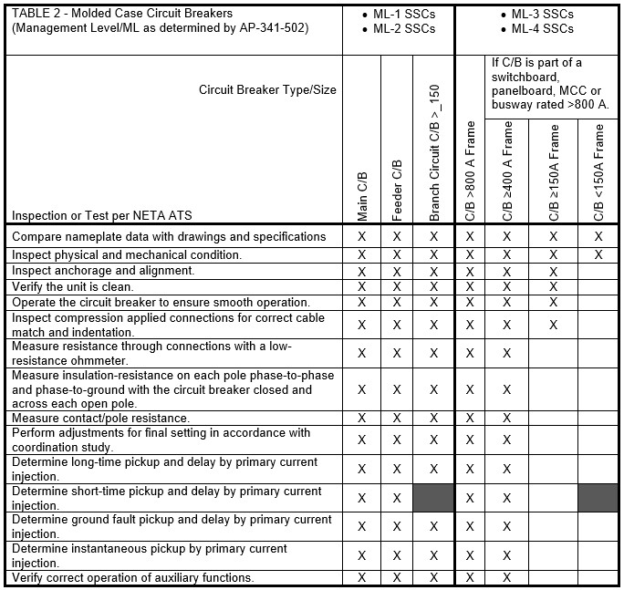
        - Section << 26 2419 - Motor-Control Centers>>.
          - << ML-1; ML-2; or ML-3>> motor control centers: Test each motor control center and each included circuit breaker. Verify that motor overload protection in each controller is appropriate for the application.
          - << ML-3; or ML-4>> motor control centers: Test each motor control center with more than 200 hp total connected load. Test included molded-case circuit breakers using the graded approach indicated in Table 2 of this Section. Verify that motor overload protection in each controller is appropriate for the application.
        - Section << 26 2500 - Enclosed Bus Assemblies>>.
          - << ML-1; ML-2; or ML-3>> enclosed bus assemblies: Test each enclosed bus assembly and each associated bus plug circuit breaker.
          - << ML-3; or ML-4>> enclosed bus assemblies: Test each enclosed bus assembly rated more than 800 amperes. Test associated bus plug molded case circuit breakers using the graded approach indicated in Table 2 of this Section.

******************************************************************************

Metering is tested by LANL Utilities. Only retain the following subparagraph if LANL-UI requests for it to be included in this Section.

******************************************************************************
        - Section << 26 2713 - Electricity Metering>>.
          - LANL will inspect, test, adjust, and program metering installed under << 26 2713 - Electricity Metering>>.
          - << ML-1; ML-2; or ML-3>> low-voltage systems: Test metering for each system and circuit.
          - << ML-3; or ML-4>> low-voltage systems: Test metering for each system and circuit rated more than 800 amperes.
        - Section << 26 2816 - Enclosed Switches and Circuit Breakers>>.
          - << ML-1; ML-2; or ML-3>> enclosed switches and circuit breakers: Test each enclosed switch and circuit breaker.
          - << ML-3; or ML-4>> enclosed switches and circuit breakers: Test each enclosed switch rated greater than 800 amperes. Test enclosed molded case circuit breakers using the graded approach indicated in Table 2 of this Section.
        - Section << 26 2913 - Enclosed Controllers>>
          - << ML-1; ML-2; or ML-3>> enclosed controllers: Test each enclosed controller. Verify that motor overload protection is appropriate for the application.
          - << ML-3; or ML-4>> enclosed controllers: Test each enclosed controller supplying a motor larger than 100 hp. Verify that motor overload protection is appropriate for the application.
        - Section << 26 2923 - Variable Frequency Motor Controllers>>
          - << ML-1; ML-2; or ML-3>> variable frequency motor controllers or adjustable speed drive systems: Test each variable frequency motor controller or adjustable speed drive system.
          - << ML-3; or ML-4>> variable frequency motor controllers or adjustable speed drive systems: Test each variable frequency motor controller or adjustable speed drive system supplying a motor larger than 60 hp.
        - Engine-Generators
          - << ML-1; ML-2; or ML-3>> engine generator assemblies: Test each engine generator assembly.
          - << ML-3; or ML-4>> engine generator assemblies: Note: Optional Standby Systems do not have an <<NFPA 110>> level.
            - Test each <<NFPA 110>> Level 1 engine generator assembly
            - Test each <<NFPA 110>> Level 2 engine generator assembly rated more than 150 kW.
        - Section << 26 3353 - Static Uninterruptible Power Supply>>
          - << ML-1; ML-2; or ML-3>>​ uninterruptible power supplies: Test each UPS.
          - << ML-3; or ML-4>> uninterruptible power supplies: Note: Systems not critical to human life do not have an <<NFPA 111>> level.
            - Test each <<NFPA 111>> Level 1 UPS.
            - Test each <<NFPA 111>> Level 2 UPS rated more than 150 kW.
        - Automatic Transfer Switches
          - << ML-1; ML-2; or ML-3>> automatic transfer switches: Test each automatic transfer switch.
          - << ML-3; or ML-4>> automatic transfer switches:
            - Test each automatic transfer switch associated with an <<NFPA 110>> Level 1 engine generator assembly.
            - Test each automatic transfer switch associated with an <<NFPA 111>> Level 1 UPS system.
            - Test each automatic transfer switch associated with an <<NFPA 110>> Level 2 engine generator assembly rated more than 150 kW.
            - Test each automatic transfer switch associated with an <<NFPA 111>> Level 2 UPS system rated more than 150 kW.

***************************************************************************************

Edit the following paragraphs and subparagraphs to match Project requirements.

***************************************************************************************
      - Tests and inspections on the following equipment and systems will be performed by either the installing firm or LANL and are excluded from the scope of this Section:
        - Addressable fire alarm system
        - Administrative access control system
        - Instrumentation and controls systems
        - Lightning protection system
        - Medium-voltage equipment, conductors, and cables

******************************************************************************

Do not activate the following subparagraph. If metering is included in this section, it will be activated in the above article "inspection and test procedures." If it is selected above, it will be deselected here. If it is not selected above, it will be activated here.

******************************************************************************
        - Electricity metering
        - Security system
        - Telecommunications system
        - Voice paging system

***************************************************************************************

Edit the following paragraphs to match Project requirements and the construction Specification for the Project. Omit paragraphs pertaining to equipment and conductors that are not included in the scope of this Project. If necessary, add references to new specification sections for equipment and conductors in the scope of the Project for which NETA-ATS has a test/inspection procedure.

***************************************************************************************
    - System Function Tests
      - The ETA shall develop and perform system function tests on the following equipment and conductors in accordance with <<NETA ATS>> after completion of the inspection and test procedures described above.

******************************************************************************

Do not activate any of the following subparagraphs independently. The following subparagraphs are activated by selecting the matching subparagraphs in the previous article.

******************************************************************************
        - Section ​<< 26 2300 - Low-Voltage Switchgear>>​​
          - Verify proper function of key interlock systems.
          - Verify proper function of main-tie-main automatic throw-over system.
          - Verify proper operation of zone-selective interlock system.
          - Verify proper operation of arc-flash reduction maintenance switch.
          - Verify proper operation of internal communications network.
          - Verify proper operation of interfaces with building automation system.
        - Section << 26 2413 - Switchboards>>
          - Verify proper operation of zone-selective interlock system.
          - Verify proper operation of arc-flash reduction maintenance switch.
          - Verify proper operation of interfaces with building automation system.
        - Section << 26 2416 - Panelboards>>
          - Verify proper operation of interlock and shunt trip systems.
        - Section << 26 2419 - Motor-Control Centers>>
          - Verify proper operation of interfaces with building automation system.
          - Verify proper operation of interlock systems.
        - Section << 26 2816 - Enclosed Switches and Circuit Breakers>>
          - Verify proper operation of interlock and shunt trip systems.
        - Section ​<< 26 2913 - Enclosed Controllers>>​
          - Verify proper operation of interfaces with building automation system.
          - Verify proper operation of interlock systems.
        - Section ​<< 26 2923 - Variable Frequency Motor Controllers>>​
          - Verify proper operation of interfaces with building automation system.
          - Verify proper operation of interlock systems.
        - Section ​<< 26 3353 - Static Uninterruptible Power Supply>>​
          - Verify proper operation of interfaces with building automation system.
          - Verify proper operation of interlock systems.
          - Verify proper operation of external maintenance bypass system.

***************************************************************************************

Edit the following article to suit project requirements. Omit studies for power systems that are not applicable to the project. Refer to the power system studies described in Article SECTION INCLUDES. In most cases, the entirety of the following Article will be omitted since this is performed by the design agency. If it is omitted, also omit this from the corresponding subparagraph in Article Action Submittals.

***************************************************************************************
    - POWER SYSTEM STUDIES
      - The ETA shall provide power system studies described below based on the installed electrical distribution system and equipment in accordance with procedures described in <<NETA ATS>> and the referenced codes and standards.
        - Include in the study the effect of all portions of the electrical distribution system including alternate sources of power.
        - Address normal system operating configuration plus any plausible alternate configurations and operations that could result in maximum fault condition.
      - Final fault current Study. Perform final fault current calculations using procedures outlined in <<IEEE 242>>.
        - As a minimum, calculate the fault current momentary and interrupting duty based on maximum available fault current at each bus in the distribution system down to the following points in the low-voltage system:
          - 480-volt system: where available fault current is less than 14,000 amperes RMS symmetrical.
          - 208- or 240-volt system: where available fault current is less than 10,000 amperes RMS symmetrical.
        - Include onsite emergency power systems and standby power systems if present.
        - Include, if present, battery systems with storage capacity greater than 1 kWh or a float-voltage greater than 100 volts.
        - Extend the fault circuit study to include the branch-circuit overcurrent protective devices for the following systems if present:
          - Safety Class Systems
          - Safety Significant Systems
          - Emergency Systems (<<NFPA 70>> Article 700)
          - Legally required Standby Systems (<<NFPA 70>> Article 701)
          - Critical Operations Power Systems (<<NFPA 70>> Article 708)
      - Final Coordination Study. Perform final coordination study using procedures outlined in <<IEEE 242>>.
        - As a minimum, include in the coordination study all voltage classes of equipment from the utility incoming line protective device(s) down to and including each low voltage load protective rated 100 amperes and larger.
        - Include onsite emergency power systems and standby power systems if present.
        - Include, if present, battery systems with storage capacity greater than 1 kWh or a float voltage greater than 100 volts.
        - Extend the coordination study to include the branch-circuit overcurrent protective devices for the following systems if present:
          - Safety Class Systems
          - Safety Significant Systems
          - Emergency Systems (<<NFPA 70>> Article 700)
          - Legally required Standby Systems (<<NFPA 70>> Article 701)
          - Critical Operations Power Systems (<<NFPA 70>> Article 708).
      - Arc-Flash Hazard Analysis. Perform arc-flash hazard analysis and shock hazard analyses based on the final system configuration. Use procedures outlined in <<IEEE 1584>> and <<NFPA 70E>>. Provide the following information in tabular form for the arc-flash warning labels described in Section << 26 0553 - Identification for Electrical Systems>>:
        - Flash hazard boundary (inches) calculated in accordance with <<IEEE 1584>> or <<NFPA 70E>>.
        - Arc-flash incident energy (cal/cm²) calculated in accordance with <<IEEE 1584>> or <<NFPA 70E>>.
        - Working distance (inches) selected from <<IEEE 1584>> or <<NFPA 70E>>(Annex D) based on equipment type.
        - Hazard/risk category number from <<NFPA 70E>> Table 130.7(C)(9) for operations with doors closed and covers on.
        - System phase-to-phase voltage.
        - Condition that exposes worker to electrical shock hazard.
        - Limited Approach Boundary from <<NFPA 70E>> Table 130.2(C) based on nominal system phase-to-phase voltage.
        - Restricted Approach Boundary from <<NFPA 70E>> Table 130.2(C) based on nominal system phase-to-phase voltage.
        - Class for insulating gloves based on system voltage (e.g., Class 00 for up to 500 volts).
        - Voltage rating for insulated or insulating tools based on system voltage (e.g., 1000 volts).
        - Equipment ID code based on Drawings and including TA number, building number, and system identifier.
        - Date that hazard analysis was performed.
        - “Supplied By” circuit directory information including the serving equipment ID code, location (e.g., room number), circuit number, and circuit voltage/phases/wires.
        - If applicable, “Supplies” circuit directory information including the supplied equipment ID code, location (e.g., room number), circuit number, and circuit voltage/phases/wires.
      - Load Flow Study. Perform load flow study using procedures outlined in <<IEEE 399>>.
      - Stability Study. Perform stability study using procedures outlined in <<IEEE 399>>.
      - Harmonic Analysis Study. Perform harmonic analysis study using procedures outlined in <<IEEE 399>>.
    - Test Report
      - The ETA shall include the following information in the final test report:
        - Summary of project.
        - Description of equipment inspected and tested.
        - Description of inspections and tests.
        - Data record resulting from each inspection and test.
        - Results of system function tests.

******************************************************************************

Retain the following if the ETA will perform a power study.

******************************************************************************
        - Power system studies and final model.
        - Analysis of the tests, identification of deficiencies, and recommendations for corrective action.
      - Include the following minimum information in each data record:
        - Identification of the ETA.
        - Equipment identification: Equipment ID code based on Drawings and including TA number, building number, and system identifier.
        - Humidity, temperature, and other conditions that may affect the results of the tests or calibration of test equipment.
        - Date inspection, test, or function test was performed
        - Identification and signature of the testing technician.
        - Description of inspections, tests, maintenance, and function tests performed and recorded.
        - Test equipment used and references to calibration records.
        - Indication of as-found condition and as-left results.
      - Submit six copies of the complete report to the LANL STR.
    - Field Quality Control
      - Report to the LANL STR, within three working days, any equipment, conductor, or installation that is found defective based on acceptance tests or inspections by the ETA.
      - Within 15 days of direction from the LANL STR, rework, repair or replace any equipment, conductor, or installation that is found defective based on acceptance tests or inspections.
      - The ETA shall retest any equipment, conductor, or installation that did not pass acceptance tests or inspections.
  - END OF SECTION

**********************************************************************************************

Do not omit the following reference information:

**********************************************************************************************
  - THE FOLLOWING STATEMENT IS FOR LANL USE ONLY
  - THIS PROJECT SPECIFICATION SECTION IS BASED ON LANL MASTER SPECIFICATION SECTION 26 0813, REV. 5, DATED APRIL 15, 2026.

